Prepared by:
Rajiv S. Jhangiani, Ph.D., Kwantlen Polytechnic University
Rebecca Pitt, Ph.D., OER Hub
Christina Hendricks, Ph.D., University of British Columbia
Jessie Key, Ph.D., Vancouver Island University
Clint Lalonde, M.A., BCcampus

EXPLORING FACULTY USE OF OPEN EDUCATIONAL RESOURCES AT BRITISH COLUMBIA POST-SECONDARY INSTITUTIONS
January 18, 2016

BCcampus Research Report

About BCcampus
BCcampus supports the work of the B.C. post-secondary system in the areas of teaching, learning and educational technology. This involves the coordination of collaborative projects that span multiple institutions, introducing and supporting innovations about the ways in which people learn, and helping institutions evaluate and develop good practice in the use of technology for learning. BCcampus also provides technologies that enable students to apply to and transfer between institutions.

About the OER Hub
OER Hub (OERH) gathers research on the impact of open educational resources (OER) on learning and teaching practices. The OERH responds to the need from the OER world for more research on which they can base decisions. The OERH shares the evidence they gather through mixed methods research including interviews, surveys, focus groups, critical incidence analysis, activity theory and analysis of learning design.

About the Open Textbook Project
The B.C. Open Textbook Project began in 2012 with the goal of making post-secondary education in British Columbia more accessible by reducing student cost through the use of openly licensed textbooks. The B.C. Open Textbook project is administered by BCcampus and funded by the British Columbia Ministry of Advanced Education.

License
This report is released with a Creative Commons Attribution license. Feel free to copy, adapt and redistribute this report as per the attribution requirements of the Creative Commons license.
This work is licensed under a Creative Commons Attribution 3.0 Unported License.

Citation
Jhangiani, R. S., Pitt, R., Hendricks, C., Key, J., & Lalonde, C. (2016). Exploring faculty use of open educational resources at British Columbia post-secondary institutions. BCcampus Research Report. Victoria, BC: BCcampus.

Table of Contents
Abstract 4
Key Findings 5
Introduction 6
Literature Review 7
OER policy 7
Barriers to use 8
Perceptions of quality 8
Method 9
Survey Design 9
Data Collection 10
Results 11
Characteristics of the Sample 11
Use of OER 12
Personality Trait: Openness 14
Purposes for Using OER 14
Types of OER Being Used 15
Perceived Quality of OER 16
Awareness and Use of Open Textbooks from the BC OTP 17
Awareness of Open Licensing 18
Barriers to Use 19
Enabling Factors 22
Perceived Impact on Learning Outcomes and Classroom Practice 23
Perceived Cost Savings to Students & Financial Benefits to Institutions 26
Institutional OER Policies 27
Sharing of Teaching Materials 28
Meaning of “Openness” in Education 28
Discussion 29
Limitations 31
Recommendations 32
Conclusion 34
References 35
Appendix A: Institutional Types 38
Appendix B: Figures 39
Appendix C: Tables 40

Abstract
This research examines the use of Open Educational Resources (OER) by post-secondary faculty in British Columbia, including their motivations and perceptions, as well as what factors help to enable or act as challenges for OER use and adaptation. Although the findings provide a snapshot of the BC post-secondary system as a whole, we also explore similarities and differences in OER use among faculty across the three institution types in British Columbia: research-intensive universities, teaching-intensive universities, and colleges/institutes (see Appendix A). This research also investigates the relationships between faculty use of OER and institutional policies, the tendency to share teaching materials, and the personality trait of openness.

Key Findings
- While faculty at all three institutional types (research-intensive universities, teaching-intensive universities, and colleges/institutes) reported similar adoption patterns of OER, faculty at research-intensive universities were more likely to adapt and create OER than faculty at teaching-intensive universities or colleges/institutes.
- Faculty who score higher on the personality trait of openness (to experience) were more likely to both adapt and create OER.
- Regardless of institutional type, the top three reasons faculty reported for using OER were for ideas and inspiration, to supplement existing coursework, and to prepare for teaching.
- The most frequently used types of OER were videos, images, and open textbooks.
- A majority of faculty perceive OER to be comparable or superior in quality to traditional, proprietary materials; however, faculty who have adopted OER rate the quality of OER significantly higher than those who have not adopted OER.
- The barriers of locating high-quality, relevant and up-to-date OER were reported to be significantly lower by faculty at research-intensive universities than by faculty at both teaching-intensive universities or colleges/institutes.
- Quantitatively, lack of institutional support for use of OER was reported as a more significant barrier by faculty at colleges/institutes than faculty at either teaching-intensive universities or research-intensive universities. However, a qualitative analysis of open-ended responses shows that faculty at all types of institutions face institutional barriers such as lack of administrative, staff, or department support for their use of OER.
- The availability of up-to-date resources from a reputable producer was reported to be relatively more important by faculty at teaching-intensive universities and colleges/institutes than those at research-intensive universities.
- On average, respondents agreed that the use of OER in the classroom benefited their students and had a positive impact on their teaching practice.
- Whereas two-thirds of respondents believe that their students save money by using OER, only one-third of respondents believed that their institution did.
- Two-thirds of respondents were unaware of any relevant institutional policy concerning OER. Faculty at teaching-intensive universities and colleges/institutes reported more encouragement to use OER than those at research-intensive universities.
These findings are expanded on in this report.

Introduction
There are close to 1.5 million full-time undergraduate students enrolled in programs at Canadian post-secondary institutions, with an additional 500,000 taking courses part-time (Government of Canada, 2015). The Financial Consumer Agency of Canada (2013) recommends that the typical Canadian student ought to budget $800-$1000 per year to cover the cost of textbooks and other required course materials. However, this estimate is likely to increase in the face of ever-rising textbook costs, which have increased by 1041% since 1977, including 82% between 2002 and 2013 alone (Senack, 2014). According to a study conducted by the Council of Alberta University Students, textbook prices increased by 2.8 times the rate of inflation between 1995 and 2014 (2014), creating a perception of academic book pricing among Canadian students as “unfair,” “overpriced”, “ridiculous”, and “expensive” (EKOS Research Associates, 2015).
One implication of these high costs has been the adoption of more economical and sometimes creative methods by students seeking to obtain required course materials. These strategies include; buying used copies, buying older or international editions, renting, sharing with classmates, using library reserve copies, photocopying, and even illegally downloading. This in turn helps explain why student spending on course materials at campus bookstores has been steadily decreasing in recent years (OnCampus Research, 2015). However, concerns over high costs still lead 65% of students to opt out of buying a required course textbook (even though 94% of these recognize doing so hurts their course performance), 49% to take fewer courses, 45% to not register for a course, and 27% to drop a course (Donaldson, Nelson, & Thomas, 2012).
It is against this backdrop that, in October 2012, the British Columbia (BC) Ministry of Advanced Education tasked the BCcampus-led Open Textbook Project (OTP) with the development of a total of 60 open textbooks in a range of subject areas, either by reusing existing open content or creating new open textbooks through innovative methods such as book sprints. Three years later, BCcampus has greatly surpassed their initial targets, with 137 open textbooks currently in the BC Open Textbook collection (and several more in development). These textbooks have been adopted in at least 300 courses at 19 (out of 25) BC public post-secondary institutions, with total savings to BC students conservatively estimated at $1,137,900-$1,414,475.
Since early 2014 the OTP has collaborated with the OER Hub (OERH), a Hewlett-funded open research project examining the worldwide impact of open educational resources (OER) on learning and teaching through an open collaborative model. This collaboration includes the present survey of post-secondary educators in BC, which was aimed at examining the following:
- how OER are currently being used;
- correlates of OER use;
- for what purposes OER are currently being used;
- what types of OER are currently being used;
- perceived quality of OER;
- awareness and use of open textbooks from the BC OTP;
- awareness of open licensing;
- individual and institutional barriers to OER use;
- individual and institutional factors that enable OER use;
- perceived impact of OER use on learning outcomes and classroom practice;
- beliefs that OER use results in cost savings to students and financial benefits to institutions;
- sharing of teaching materials; and
- how each of the above varies by the type of institution (i.e. research-intensive university, teaching-intensive university, college, or institute).
This paper presents the findings of this survey, data which provide an empirical basis for a series of recommendations for educators and policy-makers who wish to facilitate wider adoption of OER.

Literature Review
Prior to discussing the survey method and results, we briefly review some existing OER policy approaches, along with relevant data collected outside of BC concerning barriers to use and the perceived quality of OER, in order to provide some context for the results that will follow.

OER policy
Policy at both institutional as well as local, provincial, or federal government levels to increase the amount of OER used, created, and shared takes various forms. For example, funding councils often specify that research outputs are openly licensed (Government of Canada, 2014; Vancouver Foundation, 2015). However, in Canada, perhaps the most significant OER policy initiative is the 2012 Tri-Provincial Memorandum of Understanding on OER between the provinces of Alberta, Saskatchewan and British Columbia (Government of British Columbia, Government of Alberta, & Government of Saskatchewan, 2014). The agreement states that the three provinces will work collaboratively with one another on the creation and sharing of OER between the provinces (McGreal, Anderson, & Conrad, 2015).
In the United States, the Affordable Textbook Act, which went before Congress in October 2015, aims to increase the amount of openly licensed material used and shared in and by educational institutions across the nation (Durbin, 2015). Individual states, such as Utah, have also introduced a range of policies which promote more ‘open’ approaches, including one in 2009 relating to intellectual property (IP) issues (Boston Consulting Group, 2013, p. 14) and another in 2012 to engender statewide support for the creation and use of open textbooks (Wiley, 2012). In addition, post-secondary institutions in the United States have also responded to the high cost of proprietary materials with pioneering initiatives such as shifting to 100% e-resource/OER for their courses (Klein, 2015) or creating “Z-degrees” where students do not need to purchase any proprietary materials as the courses have “zero-textbook-cost” (Lumen Learning, n.d.).
In the UK, school sector initiatives have been implemented to promote the sharing of resources with an open license (Leicester City Council, n.d.) and higher educational institutions such as Leeds University (Cordell, n.d.) and Glasgow Caledonian University (Kelt, 2015) have introduced institutional policies to “encourage” educators to release their resources with a Creative Commons license. Such policies also clarify uncertainty around copyright and the IP of resources created, particularly within an employment context. Concerns about IP and copyright within the workplace are not uncommon and are likely a contributing factor to the relatively small number of OER-using educators who share their materials. OERH research reports that although many educators adapt OER and are familiar with open licensing, a much smaller number of educators reciprocally share their material with a CC license (Arcos, Weller, Pitt, Perryman, & Farrow, 2014, p. 14).

Barriers to use
Research carried out by the OERH reports the top three challenges most frequently faced by educators in all sectors (N=997) when using OER as being:
- Finding suitable resources in my subject area (58.2%)
- Finding resources of sufficiently high quality (56.1%)
- Knowing where to find resources (53.3%)
The fourth most frequently noted barrier to using OER was time, with 47.8% of educators reporting not having enough time to look for suitable resources (Arcos, Farrow, Pitt, Perryman, & Weller, 2015).

Perceptions of quality
Although the question of the quality of a resource can make reference to a number of potential aspects/characteristics (e.g., Does it align with the curriculum? Is it fit for the specific purpose? Is it error free? Is it up-to-date?), the perception of OER as ‘poor quality’ when compared with proprietary material can act as a potential barrier to OER adoption and adaptation and is therefore a key area when exploring perceptions of OER (Bliss, Hilton III, Wiley, & Thanos, 2013; Bliss, Robinson, Hilton III, & Wiley, 2013; Clements & Pawlowski, 2012).
The Boston Consultancy Group report, which focused on US perceptions and uptake of OER, revealed that “proven efficacy” and “trusted quality” were the two most important factors for potential users of OER in the K-12 sector (2013, p. 8). Yet, whereas quality is of concern to non-OER users, it is of note that only 8% and 4% of K-12 current OER users in this study report “quality” and “efficacy” respectively as their reason for continued OER use (2013, p. 20). For this group of educators who are already using OER, almost 60% report “flexibility/modularity” and “low cost” as the most important factors for their current use of OER (29% & 29%, respectively; p. 20). Quality thus appears to be less of an issue once educators are using OER and therefore more familiar with the practice of using OER, its impact on students and the potential for remix.
Improved perceptions of quality and efficacy by educators using OER are also reflected in a number of research studies: Allen & Seaman (2014) report that nearly 85% of OER using respondents thought the “proven efficacy” of OER when contrasted with proprietary resources was “superior” or “about the same” (16.5% and 68.2%, respectively) whereas over 70% of participants thought the “trusted quality” of OER was “superior” or “about the same” (12.1% and 61.5%, respectively; 2014, p. 38). Moreover, in a 2014-2015 study of OpenStax College open textbook users (which utilised the same question as used in the OTP survey reported on below), 43.5% of OSC educators told us they thought OER was “comparable” when contrasted with “traditional, proprietary materials” (n=20) whilst 47.8% of respondents said they thought OER was “significantly better” or “slightly better”. The remaining small number of respondents reported that they thought the quality of OER was “slightly worse” than that of proprietary resources (8.7%, n=4) (Pitt, 2015, p. 15).

Method

Survey Design
Hypotheses addressed by the OTP survey were based on the eleven hypothesis around which the OERH’s research is organized. Specifically, the key hypotheses the OTP study focused on were the following:
- Use of OER leads to improvement in student performance and satisfaction;
- The open aspect of OER creates different usage and adoption patterns than other online resources;
- Use of OER leads to critical reflection by educators, with evidence of improvement in their practice;
- OER adoption at an institutional level leads to financial benefits for students and/or institutions;
- Participation in OER pilots and programs leads to policy change at institutional level.
A significant advantage of working with a subset of the OERH hypotheses is that it enables comparisons across different contexts and other OERH collaborations to investigate whether and how behaviours and attitudes toward OER differ or are similar. Accordingly, the initial survey was designed by the OERH researcher and subsequently modified by the OTP project team, which included three Faculty Fellows from post-secondary institutions in BC. The final survey instrument included both closed- and open-ended questions that addressed the following themes:
- Demographic characteristics (e.g., age, gender, spoken language)
- Institutional and teaching context (e.g., institutional affiliation, type of teaching, years of teaching experience)
- Use of OER (e.g., adoption, adaptation, creation; types of OER used)
- Awareness and use of open textbooks from the BC Open Textbook Project
- Purposes of using OER
- Challenges and enabling factors for using OER
- Perceived quality of OER
- Perceived impact of OER use on learning outcomes and classroom practice
- Belief that OER use results in cost savings to students and financial benefits institutions
- Existence of (or changes in) institutional policies concerning OER
- Awareness and importance of open licensing
- Meaning of “openness” in education
- Sharing of teaching materials and reasons for (not) doing so
- Use of computers and the internet
- A brief self-report measure of the “Big Five” personality traits (openness to experience, conscientiousness, extraversion, agreeableness, and neuroticism)

Data Collection
The survey was conducted online using LimeSurvey between November 2014 and February 2015. Participants were recruited through BCcampus mailing lists and websites, social media platforms such as Twitter and Google Plus, as well as snowball sampling. Participation in the survey was incentivised by separately entering respondents’ names into a prize draw to win a Kindle e-reader. It was made clear to participants that their survey responses were kept separate from any entry into the prize draw in order to protect participant privacy.
It is important to note that the population being sampled specifically included those educators who had used OER or were interested in using OER. Consequently, the sample is not representative of all BC post-secondary educators. However, it is equally important to note that this is not a design flaw, as we were specifically interested in learning about the motivations, experiences, and perceptions of those who have already adopted (or would like to adopt) OER.

Results

Characteristics of the Sample
The sample consists of 78 educators from 17 BC post-secondary institutions (see Figure 1). Just over half of the sample (53%) reported working at a teaching-intensive university, with the remainder at research-intensive universities (14%), community colleges or institutes (14%), public institutions outside of BC (13%), or private institutions within BC (6%). Nineteen percent of the sample reported working at multiple institutions.
Figure 1: Sample by Institution
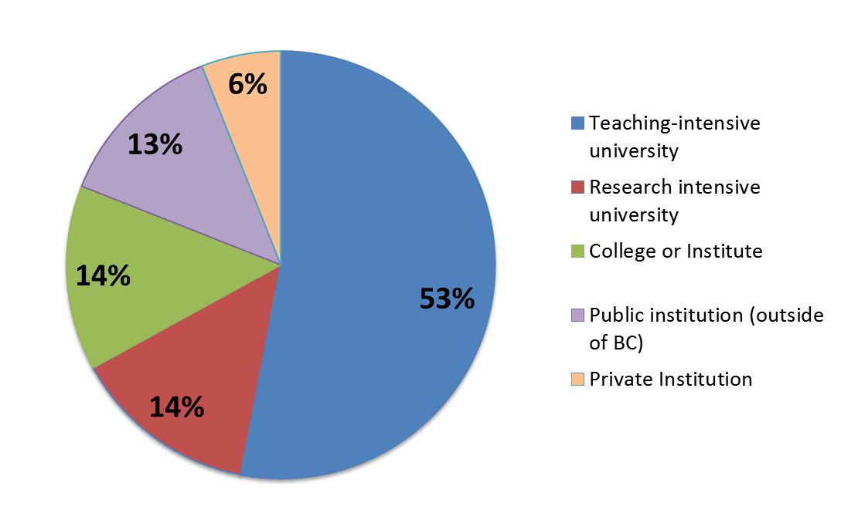
Respondents range in age from 28 to 73 (M = 53, SD = 9.94), and the ratio of female to male respondents is nearly even (46% vs. 54%). Nearly all of the participants hold either a doctorate (54%) or a Master’s degree (40%). Although the vast majority of the sample (77%) are classroom instructors, 12% are department chairs, 8% are administrators, and 5% are in technology-based positions (28% hold multiple roles). Just over half of the sample (54%) teach face-to-face (F2F) full-time, with others teaching F2F part-time (17%), online full-time (6%), online part-time (36%), blended full-time (13%), and blended part-time (6%). On the whole the sample represented fairly experienced educators (figure 2), with 72% having taught for more than 10 years.
Figure 2: Years of teaching experience
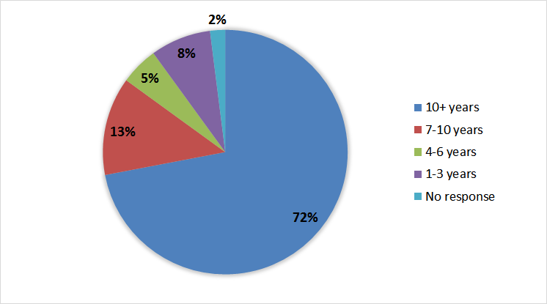
Practically the entire sample (97%) reported accessing the internet at home using a broadband connection, with a clear majority also doing so at work (85%) or at an educational institution (78%), including via a smartphone (74%) or iPad or tablet computer (71%). Relatively few reported accessing the internet at a community (e.g., library; 21%) or commercial (e.g., cyber-cafe; 23%) facility, or using a video game console (8%).

Use of OER
The vast majority of the sample (77%) reported having used OER in some fashion, whether by adopting OER for use in the classroom (60%), adapting OER to suit their specific classroom context (35%), or creating OER (28%). As can be seen in Figure 3, although OER adoption was similar across the different types of institutions, educators at research-intensive universities were more likely to report having adapted and created OER than educators at teaching-intensive universities or community colleges/institutes.
Figure 3: Use of OER by type of institution
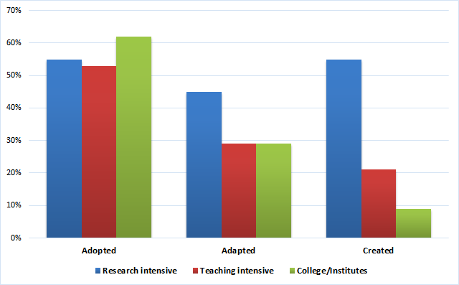
Of course, adopting, adapting, and creating OER are not mutually exclusive behaviours, and 44% of the sample reported using OER in more than one way. Accordingly, moderate positive correlations were found among each of these three behaviours (see Table 1), indicating that those who had adopted OER were moderately likely to have also adapted or created OER.
Table 1: Intercorrelations among uses of OER
 | 1 | 2 | 3
Adopting OER | - | .39 | .43
Adapting OER |  | - | .45
Creating OER |  |  | -
Note: All correlations are statistically significant at p<.001; According to Cohen (1988), correlations between .30-.50 are considered moderate.

OER creation was more likely to be reported by those using smartphones [t(57) = 4.46, p = .000] and iPads or tablet computers [t(74.68) = 2.87, p = .005], or accessing the internet at work [t(65) = 4.37, p = .000] or at an educational institution [t(60) = 4.42, p = .000], but less likely to be reported by those accessing the internet via a video game console [t(71) = -5.59, p = .000].
Figure 4 illustrates the relationships between years of teaching experience and the use, adaptation, and creation of OER. Although it appears that adaptation and creation are more common at the earliest (1-3 years) and later (over 10 years) stages of teaching career, these differences are not statistically significant (and likely due to the skew of the distribution in favour of greater experience).
Figure 4: OER use, adaptation, and creation by years of teaching experience
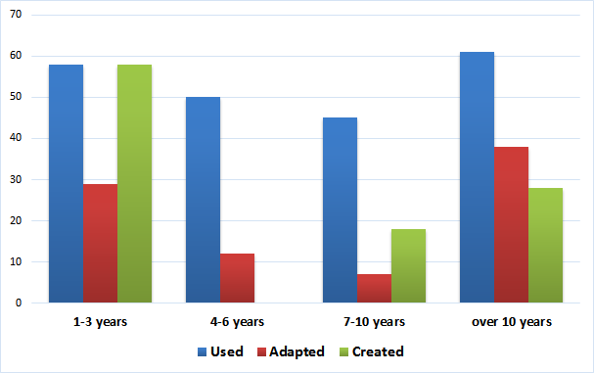

Personality Trait: Openness
Respondents who scored higher on the personality trait of openness (to experience) were more likely to report having both adapted and created OER [r(64) = .25, p = .04; r(64) = .32, p = .01]. There were no significant relationships between the other four major factors of personality (extraversion, agreeableness, conscientiousness, and neuroticism) and OER use.

Purposes for Using OER
Two-thirds of the sample reported using OER for “ideas and inspiration.” Other purposes for using OER that were reported by a majority of respondents included to supplement existing coursework (59%), to prepare for teaching (52%), and to broaden the range of resources available for learners (50%; see Figure 5 for the top 10 purposes). Less frequently cited purposes for using OER included staying up-to-date in their subject (28%), learning about a new topic (24%), to assess the quality of their materials (17%), to make their teaching more culturally diverse (15%), to interest hard-to-engage learners (14%), and to connect with instructors or learners who have similar interests (13%). Overall, although respondents were more likely to report using OER within a classroom context (e.g., for coursework or as study materials, whether optional or compulsory) than for reasons related to professional development, the breadth of responses to this question reveal the extraordinary pedagogical value of OER.
Figure 5: Most frequently cited purposes for using OER
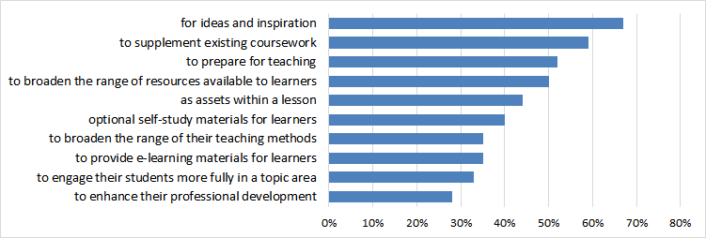
Purposes for using OER were remarkably similar across the different types of institutions (see Figure 6), although respondents from research-intensive universities were more likely than those from teaching universities and especially those from community colleges or institutes to report using OER for ideas and inspiration, to supplement coursework, as optional self-study materials, as e-learning materials, and to stay up-to-date within their subject area.
Figure 6: Purposes for using OER by type of institution
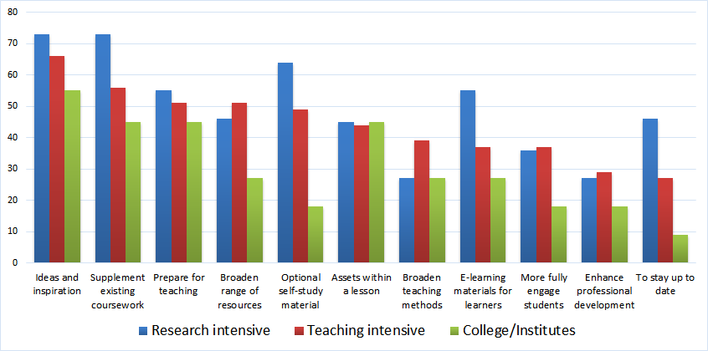

Types of OER Being Used
The most frequently used types of OER were videos (63%) and images (47%), which illustrate the common use of OER as supplementary teaching resources. Just over a third of our sample reported using open textbooks (35%) while slightly fewer (32%) reported using elements of a course. Figure 7 shows the 10 most used types of OER.
Figure 7: Most frequently used types of OER
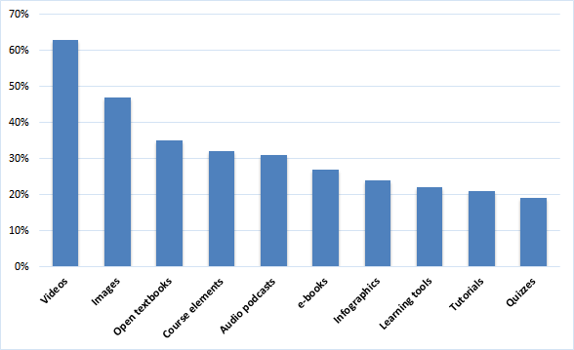

Perceived Quality of OER
When asked to rate the quality of OER, 59% of the 37 respondents who answered this question rated OER as comparable, slightly better, or significantly better than traditional, proprietary materials (see Figure 8). Interestingly, those educators who had adopted OER rated the quality of OER as significantly higher than those who had not adopted OER [1.88 vs. 3.28 on a 5-point Likert scale; F(1, 35)=7.88, p=.008].
Figure 8: Perceived quality of OER relative to traditional, proprietary materials
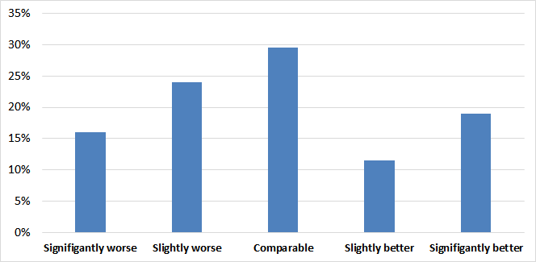
When invited to support their ratings with comments, respondents were generally quite positive about OER:
“Customization to the lesson you are teaching and is more relevant and up to date.”
“Less expensive, current, and readily available using instructional technology.”
“Solid product, searchable, and with links.”
While others noted deficiencies within existing OER and especially the availability of ancillary resources:
“It's often difficult to find materials in my subject area. The open texts I've reviewed have not been as high quality or have been lacking support materials.”
“The quality of the images and lack of supplementary material is a huge detriment.”
However, several respondents noted that the quality of the resource mattered less than its effective use:
“For the most part, again it is not so much the resource but how you engage its use in learning.”
“Well quality to me defined as if my students are able to learn from the content, its a good quality. weather [sic] it is OER or proprietary.”
Other respondents noted great variation in the quality of OER:
“‘Quality’ is often in the eye of the user - while production standards may be lower in OER, their flexibility and range of options add value.”
“There is good and poor quality OER and non-OER stuff out there.”
“It really depends on the discipline and it really depends on the resource.”
“In the past, it's taken quite a bit of work to find good quality open resources. This seems to be changing though.”

Awareness and Use of Open Textbooks from the BC OTP
Seventeen respondents (22%) reported using an open textbook from the BC OTP. When asked about how they learned about the BC OTP, these respondents cited presentations at conferences or workshops (16), referrals from colleagues (12), emails or newsletters from BCcampus (9), conducting a review of an open textbook (8), and searching online for resources (7). Among the remaining majority, the most significant reason for not using open textbooks from the BC OTP was the unavailability of a textbook for their discipline or course (see Figure 9).
Figure 9: Reported reasons for not using open textbooks from the BC OTP
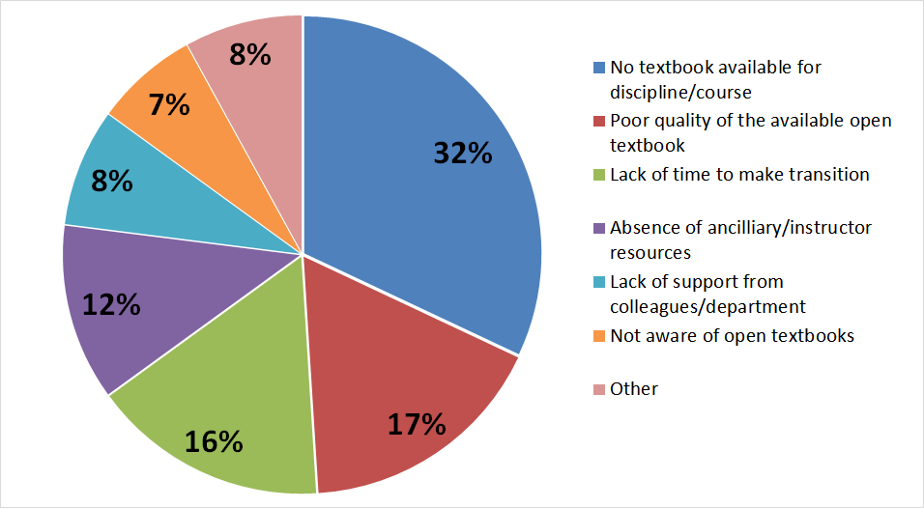

Awareness of Open Licensing
Given the widespread use of OER among our sample, it is perhaps unsurprising that the respondents were quite familiar with open licensing, with 69% recognizing and knowing the meaning of the Creative Commons logo. Furthermore, a clear majority reported that open licensing was “very important” (53%) or “important” (22%) to them when using resources in their teaching (see Figure 10).
Figure 10: Perceived importance of open licensing when using resources for teaching
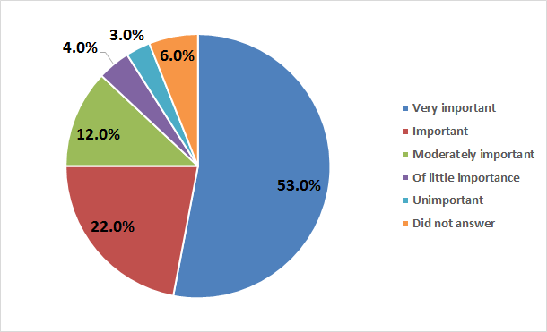

Barriers to Use
The top 10 barriers to using OER (as identified by our sample) are shown in Figure 11. As can be seen, locating relevant and high quality OER appear to be the most significant challenges identified by our respondents (58% and 49%, respectively). Also significant is the lack of time faculty experience to look for OER (39%) or to try the OER themselves to determine their relevance and quality for themselves (28%). Interestingly, whereas 19% of our sample noted unsupportive colleagues as a challenge to OER adoption (understandable especially in cases where instructional materials are selected by committee), only 13% of our sample specifically noted an unsupportive institution as a challenge.
Figure 11: Most significant barriers to OER adoption
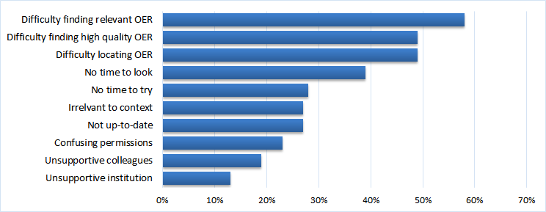
Looking at barriers by the type of institution it becomes clearer that educators at research-intensive universities do not experience quite as much of a challenge in locating relevant, high-quality, and up-to-date OER (or having the time to search for these) as those at teaching-intensive universities and community colleges/institutes (see Figure 12). This may reflect a range of factors, including teaching loads and available institutional resources (including staff with relevant expertise).
Figure 12: Most significant barriers to OER adoption, by type of institution
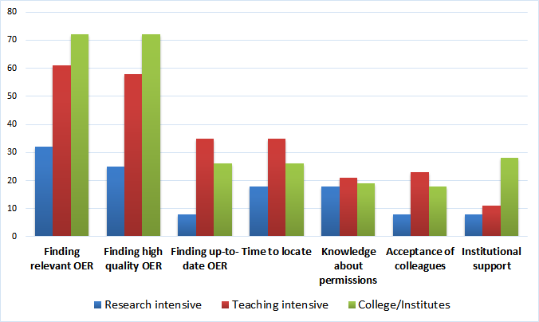
In order to capture any barriers to adopting OER that were not already listed in the survey instrument, respondents were posed an open-ended question about barriers to using OER they had encountered at their own institution. These qualitative responses were categorised and whilst 41% of these respondents reported no explicit barriers to using OER at their institution, by far the largest number of comments (31%) highlighted lack of administrative, staff, or departmental support for use of OER, followed by concerns about poor quality (12%) and the availability/opportunity to use OER (7%).
University or department policies, including those that mandate the standardization of course materials were more likely to be cited as a barrier to the use of OER by respondents at teaching-intensive universities (41%) than at research-intensive universities (14%) or community colleges/institutes (16%):
“Requirements to match all courses within the University to the same text and outcomes”
“Our dean is pressuring us to use the same resources for a multi-section course, so if one of us wants to try open resources it would be difficult.”
“I have been interested in promoting the use of the Open Text at [institution] but I do not teach the introductory courses it is designed for. There is a lot of delicacy involved in trying to raise the issue because of concerns of stepping on people's feet. In particular, the commercial text currently being used was written by the current instructor. At [institution], the courses that the textbook would apply to have just gone through major revision, so despite support for the Open Text it is unlikely that they are going to be revised again in the near future.”
“Not allowing much use of tools outside the LMS/ILP.”
Some responses highlighted the need for training to enable educators to find, use, and adapt OER effectively:
“Two barriers: (1) where to access the resources in a timely manner and (2) limited OERs related specifically to my focused discipline [nursing]”
“Adaptation of the OER materials to my courses.”
“Just around copyright law as it obtains to an OER.”
“I just don't understand the process; I don't know where these resources are; I don't know who has access how, when, where. I don't know how that student access impacts student privacy, which we must uphold. If students are going on third party sites, we have to get their consent. Where is the support that tells us how to uphold the laws?”
The time required to review and then ‘localise’ resources by adapting material to one’s own context was also highlighted as an issue by one instructor, along with the absence of ancillary materials:
“No time to check them out carefully. Some are very American and would take work to adopt. Some not as good as other texts that come with student DVD and instructor resources etc...extras”
Within the contexts described above it would be a challenge to use or experiment with open resources. However, other respondents reported a seemingly different and more positive experience. Such variation in response reflects important differences between institutions in the province and the amount of autonomy that educators are given:
“None, Our institution is very flexible and encourages faculty to explore new areas.”
“None, no one has mentioned cutting into book store profits yet…”
“None. Any perceived barriers would be self-imposed. Nothing prevent me or colleagues from actively using OER. I use OER.”
One instructor who had already been using OER described how his “barriers” were the time it took to “adapt” OER and develop other materials to provide a replacement for proprietary material whilst also becoming more familiar with the fact that combining resources (or ‘remixing’ them) was a possibility with open materials:
“To be honest the barriers (for me) were entirely mental. I was always incorporating OER into my courses because you can do that incrementally and don't have to make a huge time investment, but forcing myself to take the time to adapt an open textbook to replace my commercial textbook that came with a flashy, interactive, enriched website was hard because I had to put in the time to make something that wasn't nearly as flashy. The other mental leap I had to make was that I didn't have to adopt one open textbook and stick with it--I could combine the available texts with various OER may eventually have something as flashy as the companion site for the commercial textbooks.”

Enabling Factors
The top 10 factors that would facilitate OER adoption are depicted in Figure 13, most of which were identified by a majority of respondents. These include the existence of resources that are relevant to interests or needs (58%), the resource being created and uploaded by a reputable institution or person (56%), being easy to download (55%), having a Creative Commons license (54%), especially one that permits adaptation (54%), and the provision of learning objectives or outcomes (51%). Across the identified enabling factors it may be useful to distinguish between those that are characteristics of the OER itself (e.g., relevant, recently updated) and those that are interpersonal or experiential factors (e.g., a personal recommendation, successful experience).
Figure 13: Most significant enabling factors for using OER
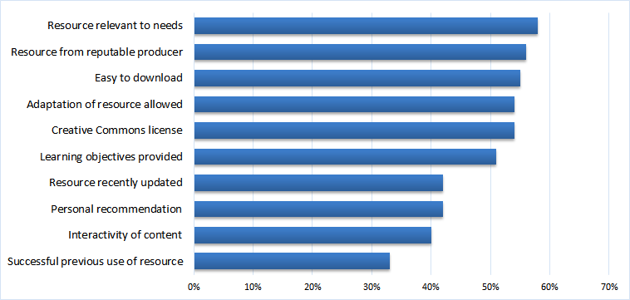
Looking at enabling factors by the type of institution, it appears that an up-to-date resource from a reputable producer is relatively more important to educators at teaching-intensive universities and colleges/institutes than those working at research-intensive universities (see Figure 14). Also worth noting is that the use of a Creative Commons license (particularly those that permit adaptation) appears to be especially attractive to those working at community colleges/institutes.
Figure 14: Most significant enabling factors for using OER, by type of institution
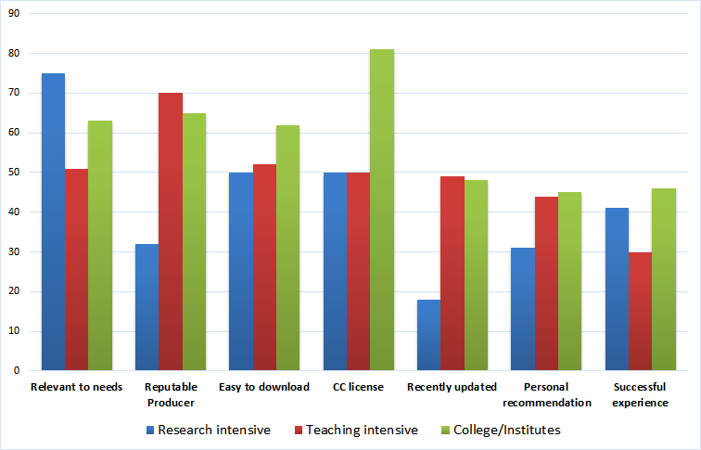
When given the opportunity to describe additional factors that would encourage the adoption of OER, nearly a third of these respondents (32%) reported that the provision of more institutional resources or incentives (e.g., time, funding, recognition, expertise) would encourage adoption of OER:
“Time/funding to search for more up to date resources.”
“The administration could create incentives (like time release) for faculty who are developing/adapting open textbooks.”
“Additional internal support through teaching and learning people and librarians.”
“Need institutional recognition - if the university supported a sabbatical leave for developing OER courses then would do it.”

Perceived Impact on Learning Outcomes and Classroom Practice
On average, respondents slightly agreed (on a 5-point Likert scale) that the use of OER in the classroom benefited their students, including by improving grades, increasing engagement with lesson content, increasing satisfaction with the learning experience, or better accommodating diverse learners’ needs (see Table 2). There were no significant differences across these beliefs between respondents from different types of institutions.
Table 2: Perceived impact of OER use on learners.
Based on responses where 1 = Strongly Disagree, 2 = Disagree, 3 = Neither Agree or Disagree, 4 = Agree and 5 = Strongly Agree.
Learning Outcomes | Average
Better accommodates diverse learners’ needs | 3.53
Increases learners’ satisfaction with the learning experience | 3.51
Increases learners’ experimentation with new ways of learning | 3.51
Increases learners’ engagement with lesson content | 3.47
Increases learners’ participation in class discussions | 3.39
Increases learners’ interest in the subjects taught | 3.35
Leads to improved students’ grades | 3.27
Develops learners’ increased independence and self-reliance | 3.25
Leads to learners becoming interested in a wider range of subjects | 3.25
Increases collaboration and/or peer-support among learners | 3.21
Increases learners’ enthusiasm for future study | 3.18
Builds learners’ confidence | 3.12

When given the opportunity to support their ratings with comments, several respondents pointed to their personal experiences:
“Personal experience that students like the online material, and free resources. better student questions..”
“I went all OER fall 2014 and completion went up significantly. I also gave a pre and post test of course objectives and 100% of students increase percentage right and the average went from a 40% on pretest to 70% on theorist test.”
“Students comment in evals that they like the diverse materials used for teaching in the classroom.”
“A student feedback survey suggested increased level of engagement.”
“I think when resources are free and easily accessible students are much more likely to access them. When I post links to videos on Youtube, I can tell students watch, and when I use free resources students that don't buy textbooks will have access to the materials.”
Other respondents described benefits of OER use within the broader context of classroom practice:
“What I primarily look for is variety on a topic: I might post a short written lecture, and then look for an interactive tutorial that explains the concept or task. Then I might look for a very short video that demonstrates a concept. The other thing I often do is post "extras" on my course site--these are usually OERs related to the topic that students are not required to view, but can if they are interested in learning more about the topic.”
“I don't believe OER's increase the learning within a subject area, per se.. But I do think they introduce students to new ways of learning and familiarize them with digital literates and responsible use of the Internet for academic studies. Instructor modeling is key.”
“The ability of a student to explore additional info outside of class helps.”
Respondents also perceived a slight positive impact of OER use on their teaching practice, including through making wider use of multimedia, using a broader range of teaching and learning methods, and reflecting more on the ways that they teach (see Table 3). The only dimension on which the mean response fell below the neutral point was “I collaborate more with colleagues.” Once again, there were no significant differences across these beliefs between respondents from different types of institutions.
Table 3: Perceived impact of OER use on classroom practice.
Based on responses where 1 = Strongly Disagree, 2 = Disagree, 3 = Neither Agree or Disagree, 4 = Agree and 5 = Strongly Agree.
Classroom Practice | Average
I use a wider range of multimedia | 3.74
I use a broader range of teaching and learning methods | 3.68
Reflect more on the way that I teach | 3.57
Improved information and communication technology skills | 3.4
Broadened my coverage of the curriculum | 3.32
More up-to-date knowledge of my subject area | 3.31
Make use of more culturally diverse resources | 3.24
Frequently compare my own teaching with others | 3.15
Now use OER to develop my teaching | 3.12
Collaborate more with colleagues | 2.79

Representative comments included the following:
“By having more access to OER, I have had recent discussions with colleagues in relation to team teaching course content and changing the format of courses significantly - something that fits the 21st cen. learner better as far as I can tell.”
“I believe that more diversified sources provide me with a greater breadth of knowledge to pass along to students.”
“Faculty need to continuously learn and adapt their teaching methodologies to align with the learners we encounter. Using OERs is one method of providing many different opportunities for students to gain exposure to the content.”
“I've noticed in the past two or three years that OER are now often created by universities and seem to be of higher quality (and more interactive) than in the past. The open textbooks that were available in my area were not very interactive--they are just e-books, but a new one has recently been developed and it's very enriched with short films and links to other cool stuff. I can only imagine OER getting better and better with the passage of time and increased adaptations of material.”

Perceived Cost Savings to Students & Financial Benefits to Institutions
Although nearly two-thirds of respondents (65%) believed that their students had saved money by using OER, only 33% of respondents believed that their institution benefited financially from the use of OER (see Figures 15 and 16). This disconnect suggests that BC educators may be unaware that cost savings to students can accrue additional benefits to the institution, such as improved student retention and program completion rates (Hilton & Laman, 2012; Robinson, Fischer, Wiley, & Hilton, 2014).
Figure 15: Belief that students save money by using OER
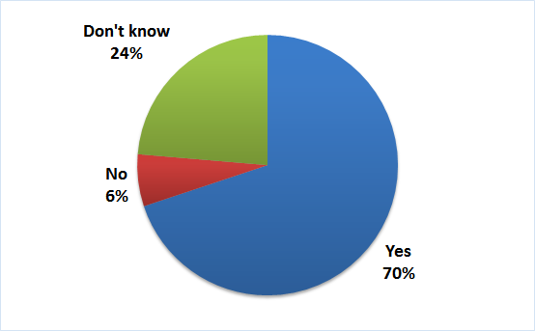
Figure 16: Belief that their institution benefits financially from the use of OER
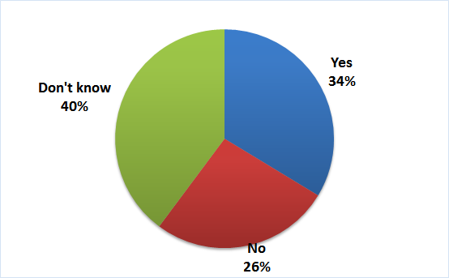

Institutional OER Policies
When asked about whether their institution had explicit policies or procedures concerning OER, two thirds of respondents (66%) reported that their institution did not have any relevant policy or that they were unaware of any specific policy (see Figure 17). Encouragement of the use of OER varied by type of institution, with participants from research-intensive universities reporting less encouragement (14%) than those from either teaching-intensive universities (39%) or community colleges/institutes (30%). However, only two respondents (both working at community colleges) reported that this encouragement was supported through specific grants or other incentives. Finally, only one respondent (working at a teaching-intensive university) reported being actively discouraged to adopt OER.
Figure 17: Institutional OER policies, by type of institution
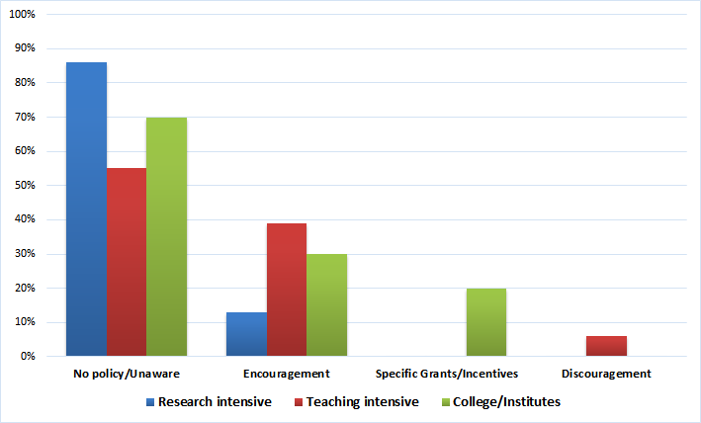

Sharing of Teaching Materials
In order to provide some insight into inclinations to adopt OER (and because of the relatively low awareness of OER among many faculty), the survey included questions pertaining to the sharing of teaching materials. However, only 13 respondents completed this section of the survey. Of these, six reported sharing their teaching materials with their colleagues (but only when asked), three reported sharing their teaching materials publicly (with two of these explicitly adopting a license that permits revision and reuse), while two reported sharing their teaching materials only with students. When asked about their motivations for sharing, the respondents cited fairness, providing assistance to others, and collaboration. Among the reasons listed for not sharing one’s teaching materials were university ownership of teaching materials (reported by 7 respondents), no forum or place to share (6), not knowing how to share teaching materials (5), enjoying more control over materials when not sharing (2), insufficient time (2), and either deriving no benefit or facing detrimental consequences (2).
Thirty-eight respondents answered questions about whether they faced any institutional or policy barriers to sharing their teaching materials publicly. Of these, the majority (21) reported experiencing no barriers while about a third (12) cited university ownership/copyright policies. Other responses included beliefs that sharing relinquishes the instructor’s rights to the materials (2), that their teaching materials were their “competitive edge” (1), and that sharing teaching materials with students would lead them to not continue in school (1).

Meaning of “Openness” in Education
Finally, we asked respondents to describe, in their own words, what “openness” in education meant to them. The most common themes to emerge were those of access/availability (44%), sharing knowledge/democratizing education (27%), the use of the “5R” permissions (to reuse, revise, remix, retain, and redistribute; 13%), openness to a diversity of perspectives (10%), pedagogical innovation (7%), transparency/accountability (5%) and collaboration (5%). Comments included the following:
“I think openness is a pedagogical/political philosophy committed to increasing access and democratizing education.”
“Free education to anyone who wants it and the encouragement for citizens to be fully educated complex thinking individuals.”
“Better access. News ways of thinking about classroom materials. Wide range of options. Teaching to the content and the learner's needs rather than teaching to the book.”
“Greater openness in terms of pedagogy. An ability to learn from others in the field, with regards to how they have developed their courses and how they have created environments that foster active learning. I love open resources, as they allow me to learn from a diverse range of experts with regards to how material is covered, different ways to connect with students.”

Discussion
This survey represents the first systematic attempt to study the attitudes and experiences of current and potential OER users at post-secondary institutions in British Columbia. Although the results of this survey reinforce several of the conclusions from previous research, the analyses of OER use along with associated barriers and enabling factors by type of institution addresses a gap in the research literature while providing an empirical basis for the specific and tangible recommendations that follow.
Almost four out of five respondents had used OER in some capacity, whether for ideas and inspiration, to supplement coursework, to prepare for teaching, or to broaden the range of resources available to learners. Videos and images were the most frequently used types of OER, followed by open textbooks, and elements of a course. Just over a fifth of the sample reported having adopted textbooks from the BC OTP, with the remainder citing the unavailability of a relevant textbook as their principal barrier.
OER use was remarkably similar across the different types of institutions and was a moderate predictor of OER adaptation and/or creation, which suggests that use may be a gateway to the use of the permissions to revise and remix these types of resources. That being said, respondents working at research-intensive institutions were more likely to report having adapted and created OER. This tendency is perhaps more easily understood through the lens of the reported personal and institutional barriers.
To our knowledge, this survey is the first study to explore the relationship between OER use and educator personality traits. Only one of the “Big 5” factors of personality was found to relate to OER use—the factor known as “openness,” which in this context refers to openness to experience and to trying new things (including the unconventional). This perhaps explains why those educators who scored higher on this trait were more likely to have adapted and/or created OER. In other words, there is indeed such as thing as openness to openness in education.
Overall, the most frequently-cited barriers to OER use in this survey correspond quite closely to those listed in the OERH report (Arcos et al., 2014), namely finding relevant, high quality resources, and having enough time to search for them and assess their quality. Other barriers reported by our sample (albeit to a lesser degree) included unsupportive colleagues (e.g., within one’s academic department) and an unsupportive institution (in terms of both policy and personnel). All of these barriers were especially likely to be reported by educators working at teaching-intensive universities. Together with heavier teaching loads and sparser institutional resources, these barriers may explain their lesser likelihood of adapting and creating OER. This interpretation is further supported by the finding that faculty at teaching-intensive institutions were most likely to report that additional institutional resources or incentives would encourage their adoption of OER.
A majority of respondents rated OER as comparable to, or better than, proprietary, publisher-produced instructional materials. This mirrors the findings of Allen & Seaman (2014) and Pitt (2015), who found that the majority of educators who had used or were familiar with OER rated their quality as equal to or higher than that of traditional educational resources. However, our results additionally demonstrate that those who had used OER rated the quality of OER more highly than those who had not.
This survey also provides new information about factors that enable OER use among faculty. Relevance to needs, as well as various indicators of quality (produced by a reputable source, recently updated, recommended by someone one knows, and having had a successful experience with an OER in the past) place high on the list. Equally high are some technical factors, such as ease of downloading and the freedom to use and adapt the resource, as indicated by an open license (such as a Creative Commons license).
A more surprising result is that although most of the enabling factors for use of OER were similar amongst institution types, the factors of OER being produced by a reputable source and having been recently updated were cited as much more important by those at teaching universities and colleges/institutes than by those at research universities. We can only speculate why this result emerged from the survey, but it is possible that the reasons for this pattern mirror the general tendency for educators at teaching-intensive universities to be less likely to report adapting and creating OER. That is, with less time and fewer resources to locate relevant and high-quality OER, faculty at teaching-intensive universities may not be in a position to take advantage of the permissions to update and otherwise adapt OER to their courses. As a result, they may be especially reliant on direct (e.g., up-to-date resources) and indirect (e.g., reputable producer) indices of OER quality.
On average, the respondents were in slight agreement that the adoption of OER has a positive impact on both students’ learning outcomes as well as their own teaching practice. The respondents also appeared quite well aware of the significant cost savings to students that result from the adoption of OER; however, awareness of the resulting benefits to the institution (e.g., on enrolment, completion, and retention) was low. This gap may also help explain why most respondents were also unaware of any institutional policy concerning OER. At least for the moment, then, in BC the decision to adopt OER appears to be largely confined to individual faculty who have the knowledge, time, inclination, and freedom (e.g., not restricted by unsupportive colleagues) to make this choice. However, as much as this suggests that the OER movement has a long way to go in BC, the findings from this survey provide a path forward in terms of several specific strategies to encourage more OER use, adaptation, and creation.

Limitations
There are several limitations to this survey, including that (as previously noted) the respondents to this survey were self-selected and therefore the results cannot be taken as representative of the views of faculty in postsecondary institutions in BC. The methods for disseminating the survey favoured faculty members who were already likely to be aware of and have used OER in the past: the survey was sent to people on email lists provided by BCcampus (many of whom would be aware of the OER work BCcampus has done in the past), publicized through social media accounts of people already familiar with OER, and through snowball sampling through those who had already received the survey. Thus we do not have much representation in the data of the views of those entirely unfamiliar with OER (as noted above, 77% of respondents reported having used OER in some fashion). However, as most of the respondents were familiar with and have used OER, the survey provides useful information about how such faculty perceive OER quality, barriers and enabling factors regarding their use, as well as institutional and other policies.
The results are also limited in that there was a much greater number of respondents from teaching-intensive universities (61% of the sample) than from colleges/institutes or research-focused universities (16% each). The results regarding institutional differences, noted above, may be somewhat less reliable due to this significant discrepancy. It is possible that if there were more respondents from research universities, some of the comparisons and contrasts against responses from faculty at teaching-intensive institutions may have been significantly different.
All of the questions in the survey were optional. In general, open-ended questions had a higher non-response rate. These include questions pertaining to institutional policies that would encourage them to be more open (45%), institutional barriers to using OER (42%) or sharing teaching materials (40%), the experience of using OER at their institution (33%), institutional practices or policies regarding OER (26%), reasons for sharing (or not sharing) teaching materials (23%), and the meaning of “openness” in education (21%). Closed-ended questions that remained unanswered by more than 10% of respondents concerned the perceived quality of OER (53%), institutional affiliation (19%), personality characteristics (18%), and the impact of OER on teaching practice (13%).
Finally, the length of the survey may have been an obstacle for at least some respondents. The survey included 38 questions that the informed consent form advised would take 20 minutes to complete. The median amount taken by the 78 respondents who completed the survey was 15 minutes 39 seconds. However, 40 incomplete responses were recorded, almost all of which (37) represent attempts at fewer than half of the questions in the survey. These partial responses have not been analyzed or included in the summary of results above. It is possible that some of these 40 respondents attempted the survey a second time and are included among the 78 complete responses.

Recommendations
Based on the research findings the following recommendations are suggested to reduce the barriers of using OER in courses and to successfully advocate for mainstream adoption of OER:
- Institutional commitment to OER. First and foremost, institutions should raise awareness of the existence of OER; where to find these materials, how to review their quality, and how to adopt OER for courses. Awareness should also be raised of the pedagogical and financial benefits of OER to students (e.g., cost savings, flexible and permanent access, course performance), instructors (e.g., ability to adapt materials, improved learning outcomes, OER creation as course assignments), and institutions (e.g., enrolment, retention, completion). Awareness can be raised through workshops, panels (e.g., during Open Education week or other designated professional development periods), and other information sessions. These efforts might be spearheaded by institutional working groups that include students, librarians, faculty representatives, teaching and learning centre staff, administrators, and other internal stakeholders (e.g., Kwantlen Polytechnic University’s Open Studies Working Group).
- Support for adaptation and adoption is required to ensure successful adoption of OER. Teaching and Learning Centres as well as Libraries can provide expertise and support on best practices for OER adoption and adaption. Further education is recommended on copyright laws and Creative Commons licenses, preferably through the support of the Library and/or the Institution’s Copyright Office.
- Sufficient time to create, adapt, and adopt OER is a significant barrier to using OER in a course. Institutions and departments should provide release time or paid educational leave to faculty to create, adapt, and/or adopt OER.
- Internal funding should be provided to support the development or redevelopment of courses to incorporate OER (e.g. OER Resource Grants at Simon Fraser University) as well as the development of ancillary materials (e.g. video tutorials, question banks, etc). Investing in the development of ancillary resources eliminates a major barrier to open textbook adoption for faculty who rely heavily on publisher-provided resources.
- Institutional policies concerning OER should be developed and disseminated to help raise awareness, dispel myths, and to encourage members of the university community to adopt open educational practices. These university policies should ideally be tied to the university mission and academic plan.
- The creation and adaptation of OER should be appropriately recognized as curricular innovation and service to the academic profession during the tenure, promotion, and reappointment process at research-intensive universities. Without this recognition, the benefits of open educational practices will be slow to accrue at research-intensive universities.
- Faculty should be encouraged and incentivized to review open textbooks that are available in their areas of specialization. Reviewing open textbooks helps raise awareness of their existence and negates perceptions of inferior quality while also serving as a gateway to adoption and adaptation. The BC OTP offers a $250 honorarium to qualified faculty reviewers; however, institutions could augment this support or otherwise recognize these efforts.
- Faculty should be encouraged to pilot the use of OER within their courses, whether as a replacement for a paid, proprietary resource or even as a supplementary resource. These might include, for example, materials from MIT OpenCourseWare, open textbooks from the BC OTP, or open source software like R. A pilot adoption of an open textbook may also be a viable approach in cases of multi-section courses in which textbooks are selected by committee. Because students in participating pilot sections will not incur any textbook costs, the fear that students switching sections or repeating a course will have to purchase another textbook will be allayed.
- Faculty should be encouraged to design and assign non-disposable course assignments that, for example, involve students in the creation and adaptation of OER (e.g. the University of California at Davis’ ChemWiki project). These efforts require education and support through, for example, professional development workshops offered by the university teaching and learning centre.
- Faculty as well as staff at teaching and learning centres should be encouraged to design and conduct research to investigate the impact of OER adoption on educational outcomes such as course performance, program completion, and student retention. Results from this research should be disseminated widely within the institution to support evidence-based decision-making concerning OER policies and practices. Internal funding to support this research is also highly desirable.

Conclusion
Adopting open educational practices holds great promise in terms significant cost savings, innovative pedagogy, and improved educational outcomes. The results of this survey and the accompanying recommendations provide a road map for institutions not only in British Columbia, but elsewhere who are looking to reap these benefits.

References
Allen, E., & Seaman, J. (2014). Opening the Curriculum. Babson Survey Research Group. Retrieved from http://www.onlinelearningsurvey.com/reports/openingthecurriculum2014.pdf
Arcos, B. de los, Farrow, R., Pitt, R., Perryman, L., & Weller, M. (2015). OER Research Hub Data 2013-2015: Educators. OER Research Hub. Retrieved from https://oerresearchhub.files.wordpress.com/2015/09/educators_final_oerrhdata.pdf
Arcos, B. de los, Weller, M., Pitt, R., Perryman, L., & Farrow, R. (2014). OER Evidence Report 2013-2014. Retrieved from http://oerresearchhub.org/about-2/reports/
Bliss, TJ, Hilton III, J., Wiley, D., & Thanos, K. (2013). The cost and quality of online open textbooks: Perceptions of community college faculty and students. First Monday, 18(1). http://doi.org/10.5210/fm.v18i1.3972
Bliss, TJ, Robinson, T. J., Hilton III, J., & Wiley, D. (2013). An OER COUP: College Teacher and Student Perceptions of Open Educational Resources. Retrieved from http://jime.open.ac.uk/articles/10.5334/2013-04/
Boston Consulting Group. (2013). The Open Education Resources Ecosystem. Hewlett Foundation. Retrieved from http://www.hewlett.org/library/consultant-publication/open-education-resources-ecosystem
Clements, K. I., & Pawlowski, J. M. (2012). User-oriented quality for OER: understanding teachers’ views on re-use, quality, and trust: User-oriented quality for OER. Journal of Computer Assisted Learning, 28(1), 4–14. http://doi.org/10.1111/j.1365-2729.2011.00450.x
Cordell, E. (n.d.). Open Educational Resources (taught students). Retrieved January 12, 2016, from http://ses.leeds.ac.uk/info/22149/a-z_of_policies_and_key_documents/645/open_educational_resources_taught_students
Council of Alberta University Students. (2014, April). Building a Brighter Alberta. Council of Alberta University Students. Retrieved from http://caus.net/beta/wp-content/uploads/2014/04/CAUS-Lobby-Document-2014-final.pdf
Donaldson, R. L., Nelson, D. W., & Thomas, E. (2012). Florida Student Textbook Survey. Retrieved from http://www.openaccesstextbooks.org/pdf/2012_Florida_Student_Textbook_Survey.pdf
Durbin, R. (2015, October 8). Text - S.2176 - 114th Congress (2015-2016): Affordable College Textbook Act [legislation]. Retrieved January 12, 2016, from https://www.congress.gov/bill/114th-congress/senate-bill/2176/text
EKOS Research Associates. (2015). Public Opinion on the Value of Books in the Education Book Sector (p. 37). Retrieved from http://publishers.ca/images/downloads/Book%20Value%20Educ%20Sector%20Final%2031%20Mar%202015.pdf
Financial Consumer Agency of Canada. (2013, August 14). Budget for student life—How much will your post-secondary education cost? Retrieved January 11, 2016, from http://www.fcac-acfc.gc.ca/Eng/forConsumers/lifeEvents/payingPostSecEd/Pages/Budgetfo-Unbudget.aspx#books
Government of British Columbia, Government of Alberta, & Government of Saskatchewan. Memorandum of Understanding on Open Educational Resources (2014). Retrieved from http://www.gov.sk.ca/adx/aspx/adxGetMedia.aspx?mediaId=f3d342c4-ab61-44a4-9f96-71ceb7810a5d&PN=Shared
Government of Canada. (2014, October 16). Tri-Agency Open Access Policy on Publications. Retrieved January 12, 2016, from http://www.science.gc.ca/default.asp?lang=En&n=F6765465-1
Government of Canada, S. C. (2015, November 30). Postsecondary enrolments by institution type, registration status, province and sex (Both sexes). Retrieved January 11, 2016, from http://www.statcan.gc.ca/tables-tableaux/sum-som/l01/cst01/educ71a-eng.htm
Hilton, J., & Laman, C. (2012). One college’s use of an open psychology textbook. Open Learning: The Journal of Open, Distance and E-Learning, 27(3), 265–272. http://doi.org/10.1080/02680513.2012.716657
Kelt, M. (2015). Scotland: Glasgow Caledonian University OER Institutional Policy - Creative Commons. Retrieved January 12, 2016, from https://wiki.creativecommons.org/wiki/Scotland:_Glasgow_Caledonian_University_OER_Institutional_Policy
Klein, G. (2015, August 27). UMUC Replaces Textbooks with Embedded Digital Resources | UMUC. Retrieved January 12, 2016, from http://www.umuc.edu/globalmedia/embedded-digital-resources.cfm#sthash.TxueS2Is.dpbs
Leicester City Council. (n.d.). Open Education for Schools. Retrieved January 12, 2016, from http://schools.leicester.gov.uk/ls/open-education/
Lumen Learning. (n.d.). Success Story: Tidewater Community College. Retrieved January 12, 2016, from http://lumenlearning.com/success-story-tidewater/
McGreal, R., Anderson, T., & Conrad, D. (2015). Open Educational Resources in Canada 2015. The International Review of Research in Open and Distributed Learning, 16(5). Retrieved from http://www.irrodl.org/index.php/irrodl/article/view/2404
OnCampus Research. (2015). Attitudes & Behaviors Toward Course Materials. Retrieved from http://www.nacs.org/portals/nacs/uploaded_documents/PDF/Research/2015_SpringStudentWatchTakeaways.pdf
Pitt, R. (2015, May). Exploring the Impact of Open Textbooks Around the World. Presented at the Open Textbook Summit, Vancouver, BC, Canada. Retrieved from http://www.slideshare.net/BeckPitt/exploring-the-impact-of-open-textbooks-around-the-world
Robinson, T. J., Fischer, L., Wiley, D., & Hilton, J. (2014). The Impact of Open Textbooks on Secondary Science Learning Outcomes. Educational Researcher, 43(7), 341–351. http://doi.org/10.3102/0013189X14550275
Senack, E. (2014, January 27). SURVEY SHOWS STUDENTS OPTING OUT OF BUYING HIGH-COST TEXTBOOKS. Retrieved January 11, 2016, from http://www.uspirg.org/news/usp/survey-shows-students-opting-out-buying-high-cost-textbooks
Vancouver Foundation. (2015, May). Vancouver Foundation Open Licensing Announcement. Retrieved from https://www.vancouverfoundation.ca/sites/default/files/documents/Vancouver%20Foundation%20Open%20Licensing%20Announcement%20-%2005-07-2015.pdf
Wiley, D. (2012, January 25). Utah Moves to Open Textbooks. Retrieved January 12, 2016, from http://opencontent.org/blog/archives/2134

Appendix A: Institutional Types
From Public Post Secondary Institutions, BC Ministry of Advanced Education and Understanding BC’s Post-Secondary Institutions, (2014) Parady Group for BC Council of Administrative Tribunals (BCCAT).

Research-Intensive Universities
- The University of British Columbia
- Simon Fraser University
- The University of Victoria
- The University of Northern British Columbia

Teaching-Intensive Universities
- Capilano University
- Emily Carr University of Art and Design
- Kwantlen Polytechnic University
- Vancouver Island University
- University of the Fraser Valley
- Royal Roads University
- Thompson Rivers University (including TRU-Open Learning)

Colleges and Institutes
- Camosun College
- College of New Caledonia
- College of the Rockies
- Douglas College
- Langara College
- North Island College
- Northern Lights College
- Northwest Community College
- Okanagan College
- Selkirk College
- Vancouver Community College
- Justice Institute of British Columbia
- Nicola Valley Institute of Technology
- British Columbia Institute of Technology

Appendix B: Figures
Figure 1: Sample by Institution 11
Figure 2: Years of teaching experience 12
Figure 3: Use of OER by type of institution 13
Figure 4: OER use, adaptation, and creation by years of teaching experience 14
Figure 5: Most frequently cited purposes for using OER 15
Figure 6: Purposes for using OER by type of institution 15
Figure 7: Most frequently used types of OER 16
Figure 8: Perceived quality of OER relative to traditional, proprietary materials 16
Figure 9: Reported reasons for not using open textbooks from the BC OTP 18
Figure 10: Perceived importance of open licensing when using resources for teaching 19
Figure 11: Most significant barriers to OER adoption 19
Figure 12: Most significant barriers to OER adoption, by type of institution 20
Figure 13: Most significant enabling factors for using OER 22
Figure 14: Most significant enabling factors for using OER, by type of institution 23
Figure 15: Belief that students save money by using OER 27
Figure 16: Belief that their institution benefits financially from the use of OER 27
Figure 17: Institutional OER policies, by type of institution 28

Appendix C: Tables
Table 1: Intercorrelations among uses of OER 13
Table 2: Perceived impact of OER use on learners.. 24
Table 3: Perceived impact of OER use on classroom practice. 25

For context, average undergraduate tuition costs during 2014-15 was $6,191 (Statistics Canada, 2015)
Initially, the project’s remit was the creation of 40 open textbooks. This number increased to 60 with the announcement in Spring 2014 that a further 20 were to be added to the collection. See: http://bccampus.ca/open-textbook-project/
For more on the BCcampus open textbook sprints, see: http://oerresearchhub.org/2014/07/02/clint-lalonde-bccampus-reflections-on-an-open-textbook-sprint/
As of January 14, 2016. For updated statistics, see: http://open.bccampus.ca/2015/09/10/more-bc-open-textbook-stats/
26.1%, n=12 “Slightly better” and 21.7%, n=10 “Significantly better”
All eleven hypothesis used by the OERH in their research available at http://oerresearchhub.org/collaborative-research/hypotheses/
The ten-item personality inventory (TIPI; Gosling, Rentfrow, & Swann, 2003)
Another 9% recognized the logo but did not know what it means, while 19% did not recognize the logo.
Interestingly, 18% of respondents reported becoming aware of changes to institutional policies and/or practices as a result of an OER pilot or program.
Four participants noted that this question was phrased ambiguously.
See http://www.sfu.ca/oergrants.html
See http://www.neuroanatomy.ca/
See http://thatpsychprof.com/the-great-psychology-testbank-sprint/
See http://open.bccampus.ca/call-for-proposals/call-for-reviewers-2/
See ocw.mit.edu
See http://open.bccampus.ca/
See https://www.r-project.org/
See http://chemwiki.ucdavis.edu/

