BCcampus Mathtest Technical Report
Notes for setting up https://mathtest.bccampus.ca/ • May 15, 2020
Alan Levine • https://cog.dog • cogdogblog@gmail.com

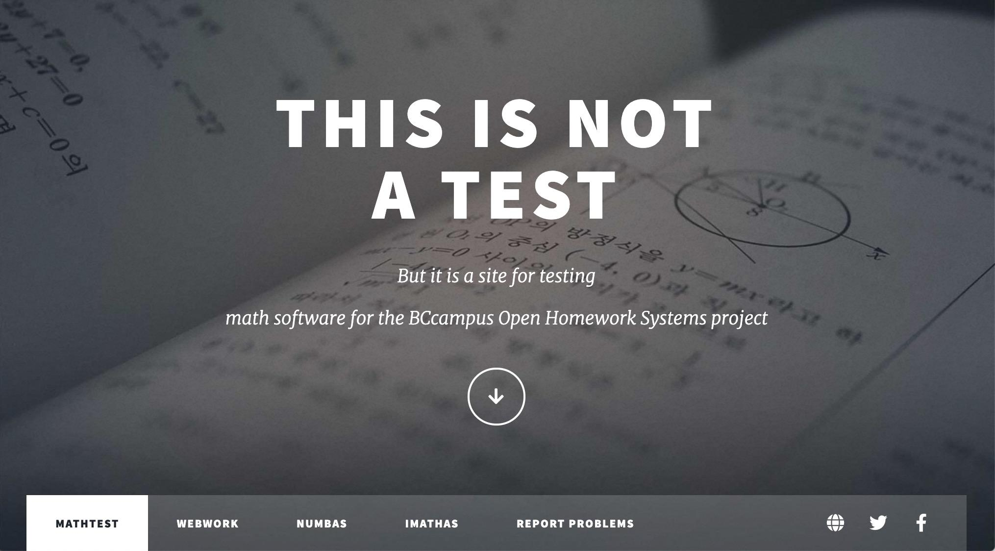

This report covers the server setup for a test site of math assessment software for the BCcampus Open Homework Systems Project. This report includes specific requirements and adjustments to the installation instructions required to run the three platforms from a cloud-hosted server, as well as approaches for importing existing content.
The platforms run under different programming languages. All three required extra steps to reach an operable stage. The platforms’ programming languages are as follows:
- WeBWorK operates in Perl and MySQL
- Numbas operates in Python and Django
- IMathAS operates in PHP and MySQL

All three were successfully installed on the same server. Moodle was also installed to test the importation of Numbas problem sets.

In addition, the report includes a section outlining the availability for learning management systems (LMSs) of LTI integration or support for SCORM importation of problem sets, as well as general commentary about the management of the apps.

Table of Contents

General Server Setup 3
Apache Web Server and Ownership 3
Website 3
CGI Scripts 4
Sendmail 5
SSL 6
Moodle 7
Problem Report Tracking Form 8
WeBWorK Installation Notes 9
Management 11
Runtime Issues 11
SSL Update 13
Importing Content into WeBWorK 13
IMathAS Installation Notes 14
Initial Installation 14
mb_string Required 15
PHP Version Bumps 16
Other Notes 16
Importing Content into IMathAS 16
Numbas Installation Notes 18
Account Activation Error 20
Importing Content into Numbas 21
Notes on Integration 22
WeBWorK Integration 22
IMathAS Integration 23
Numbas Integration 23
Summary Notes 25

General Server Setup
The server for this project was set up in BCNET EduCloud running Ubuntu (an OS recommended for and compatible with all three software platforms).
Distributor ID: Ubuntu
Description: Ubuntu 16.04.6 LTS
Release: 16.04
Codename: xenial
Server access was granted as an admin (not root), so most commands require sudo.

Apache Web Server and Ownership
Apache was installed following the instructions in the article How to Install and Configure Apache Web Server on Ubuntu.
sudo apt install apache2
This install made all web server files owned by user root and group root. Using:
sudo apachectl -S
I identified the group needed for access as www-data:
User: name="www-data" id=33
Group: name="www-data" id=33
All users (e.g., user1, user2) needing access to upload and edit content on the server were added to the www-data group:
sudo usermod -a -G www-data user1
sudo usermod -a -G www-data user2
Changing group ownership of the web directory enabled these users to upload content:
sudo chgrp -R www-data /var/www/html

Website
A basic HTML website for BCcampus Mathtest was created using the HTML5 UP template Massively, with a landing page for each application, including access links, documentation, and status updates. An archive of the BCcampus Mathtest website is available for download [ZIP file].

CGI Scripts
CGI scripts are needed by IMathAS. Enabled by:
sudo a2enmod cgi
sudo service apache2 restart
These scripts reside in /usr/lib/cgi-bin and are aliased via Apache from http://mathtest.bccampus.ca/cgi-bin.
All CGI scripts must be set permissions with 755. Click here for a CGI Script Permissions Test for BCcampus Mathtest.

Install git
Several of the application and extra module installers required command line git. Installed and configured (for the user running git) via:
sudo apt-get install git
git config --global user.email "you@example.com"
git config --global user.name "Your Name"
This user would need to generate an SSH key from git and enable it locally, following the instructions in the article Generating a new SSH key and adding it to the ssh-agent.

MySQL
Run
sudo apt-get install mysql-server
As noted in the later sections, updated versions of MySQL-related modules were required as issues arose.

PHP
PHP and several modules are required for IMathAS and Moodle. Install via:
sudo apt-get install php libapache2-mod-php php-mcrypt php-mysql
Initially, version 7.0 was installed by default, but as noted in IMathAS notes, a newer version of PHP (7.1 or newer) was required.
Create server file info.php with contents:
<?php phpinfo();?>
From the first install, here is the PHP test page for BCcampus Mathtest with version information.
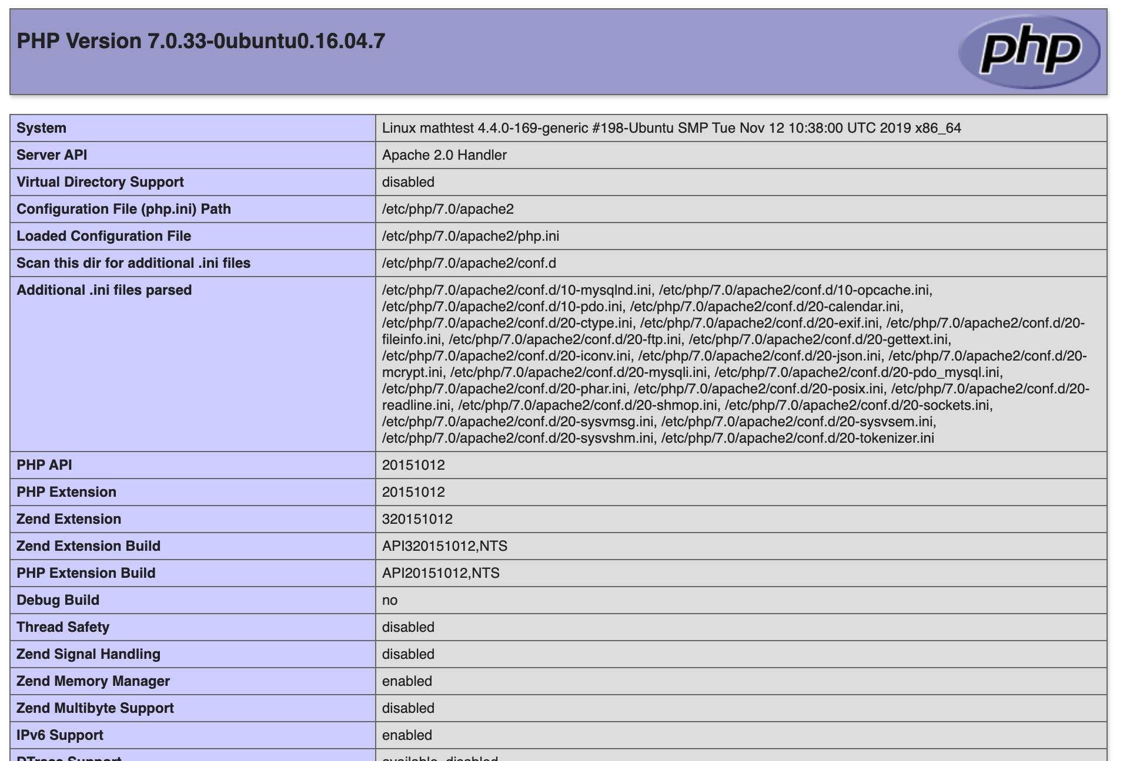

Sendmail
This was necessary for applications to send email notifications for account setup, notifications, and password resets. Postfix was setup via the instructions in the article How to Install and Configure Postfix as a Send-Only SMTP Server on Ubuntu 16.04.
With command:
sudo apt install mailutils

This did not trigger the configurations walkthrough screen as described, but I was able to access this interface via:
sudo dpkg-reconfigure postfix
This setting worked:
mydestination = $mydomain, localhost.$mydomain, localhost
An issue came up for email sent to a domain (*****@bccampus.ca) on the same domain as the server:
SMTP Recipients Refused: Recipient address rejected: User unknown in local recipient table
This was fixed with a change to the Postfix configuration (as described in a Server Fault thread about Postfix rejecting a recipient address):
mydestination = localhost.$mydomain, localhost
This can be done by running the reconfigure command or directly editing /etc/postfix/main.cf.
Most mail sent out from a server is likely to be flagged as spam. An SPF record was added (this can be checked by using the SPF checker tool DMARC Analyzer).

SSL
This should have been done from the start, but was implemented later in the testing to set up potential for LTI testing with Moodle.
A wildcard certificate was installed by our network admin.
Here is a reference for setting up SSL.
Apache config updated:
sudo pico /etc/apache2/sites-enable/default-ssl.conf
Change settings:
SSLCertificateFile /etc/ssl/certs/*******.bccampus.*******..pem
SSLCertificateKeyFile /etc/ssl/private/*******..bccampus*******..key
Enabled:
sudo a2ensite
sudo systemctl restart apache2.service

Then, set up redirects for http:// requests.
Add to /etc/apache2/sites-enable/000-default.conf in Virtual Host section
Redirect permanent / https://mathtest.bccampus.ca/
This provided SSL support to content and the WeBWorK and IMathAS applications running on mathtest.bccampus.ca, but not for Numbas running in a subdomain (numbas.mathtest.bccampus.ca). This would have required a new certificate, and for the limited testing, it was deemed not critical for the project.

Moodle
A BCcampus Mathtest instance of Moodle was created toward the latter stages of the project to test SCORM input capability for Numbas.
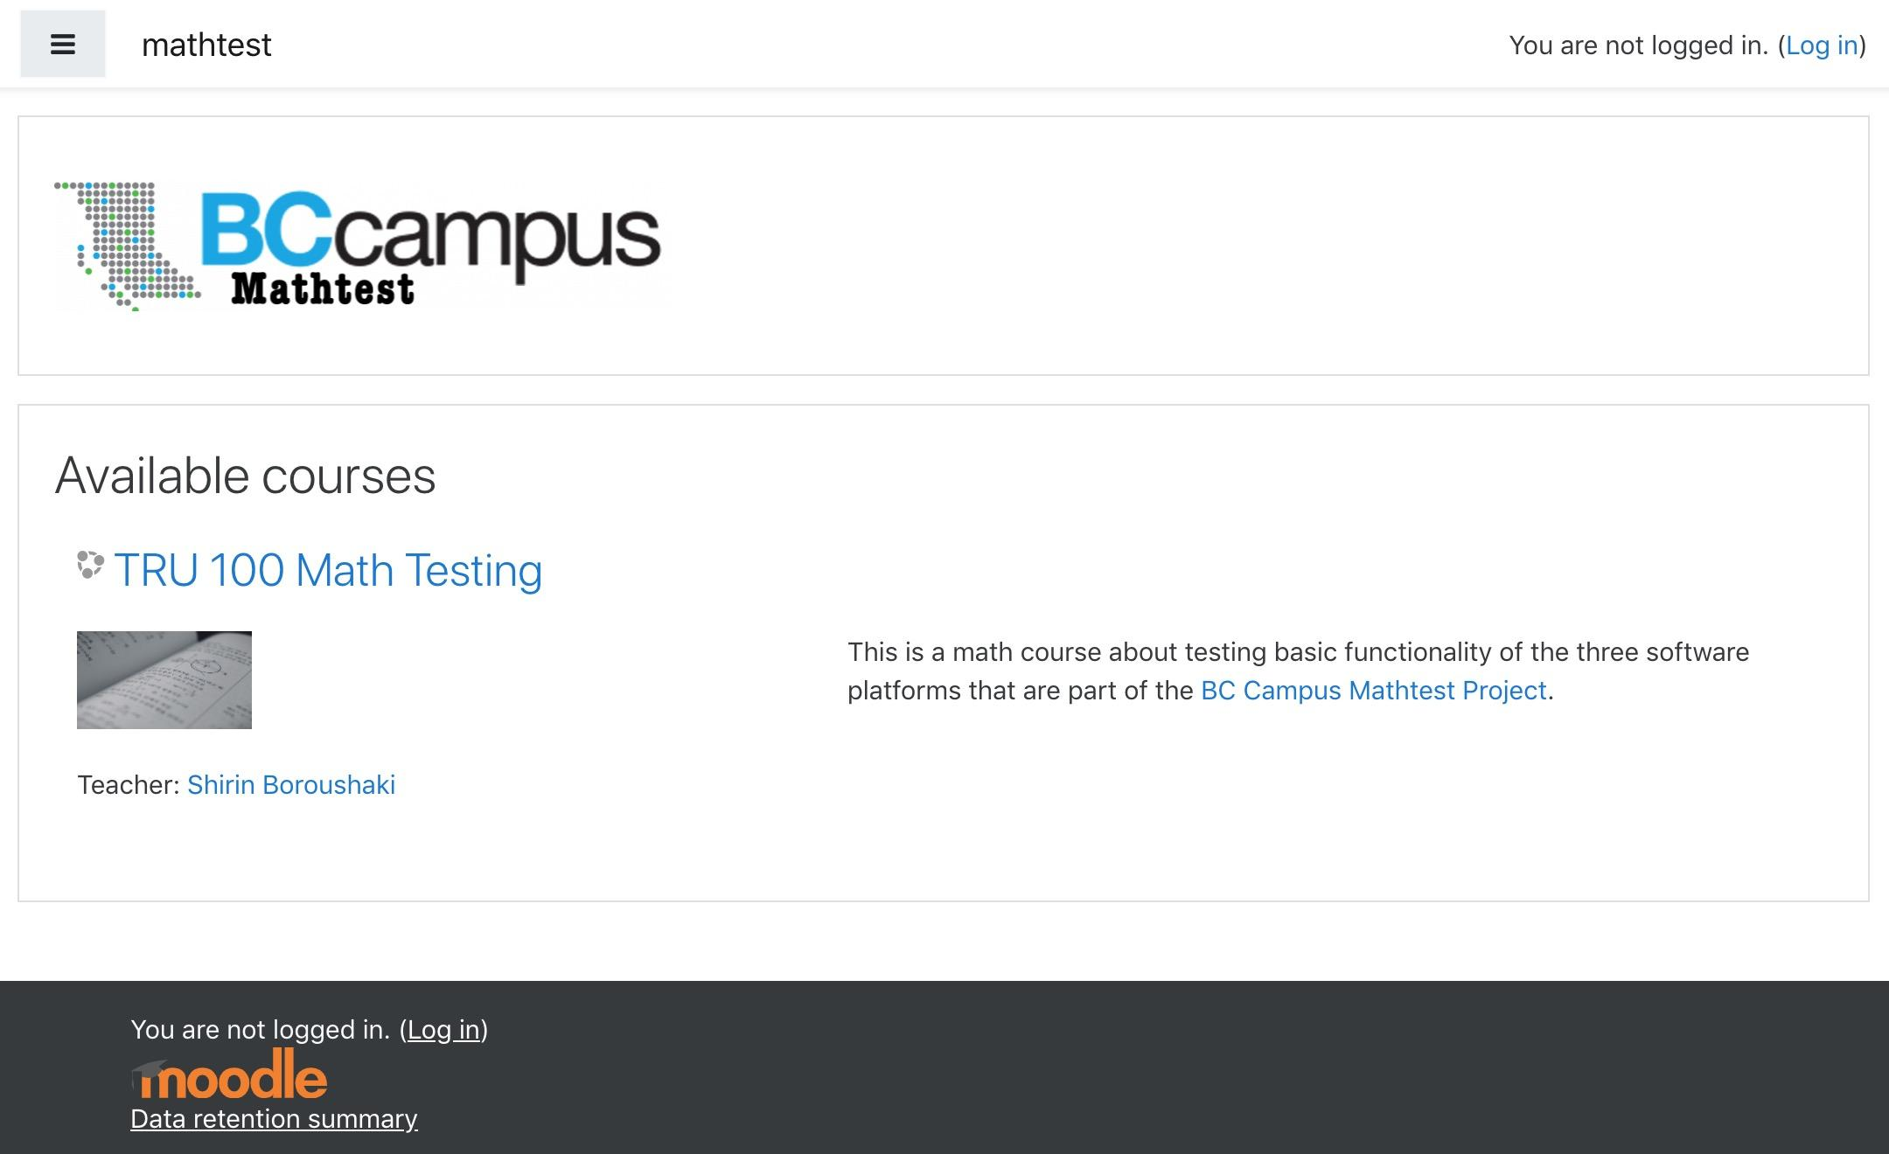

Steps followed were from Moodle’s Step-by-Step Installation Guide for Ubuntu.
sudo apt install graphviz aspell ghostscript clamav php7.3-pspell php7.3-curl php7.3-gd php7.3-intl php7.3-xml php7.3-xmlrpc php7.3-ldap php7.3-zip php7.3-soap php7.3-mbstring
Moodle was installed into /opt/moodle as described, and the MySQL database was set up and then copied to the main web directory.

One adjustment was needed to allow uploads greater than the 2 MB limit (the SCORM packages tested were ~10 MB):
sudo pico /etc/php/7.3/apache2
This changed the values of post_max_size and upload_max_filesize to be 30 MB.

Problem Reporting Form
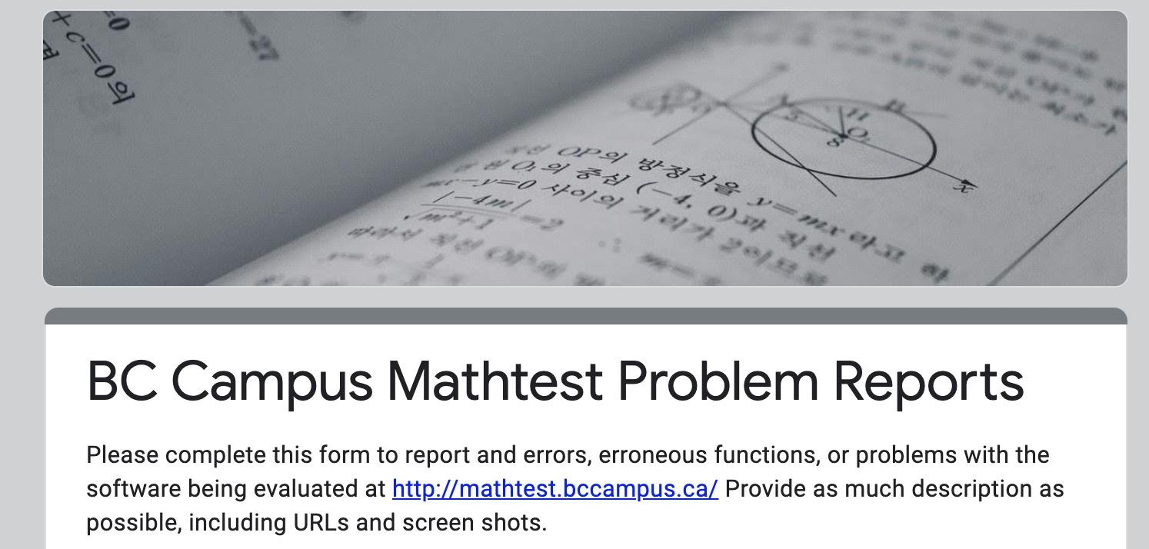

A BCcampus Mathtest Problem Reporting Google Form was created so that project participants could report issues, bugs, etc. It was only lightly used, with seven reports. The BCcampus Mathtest Problem Reports spreadsheet includes a page with a summary of issues and a response status, added after issues were addressed.

WeBWorK Installation Notes
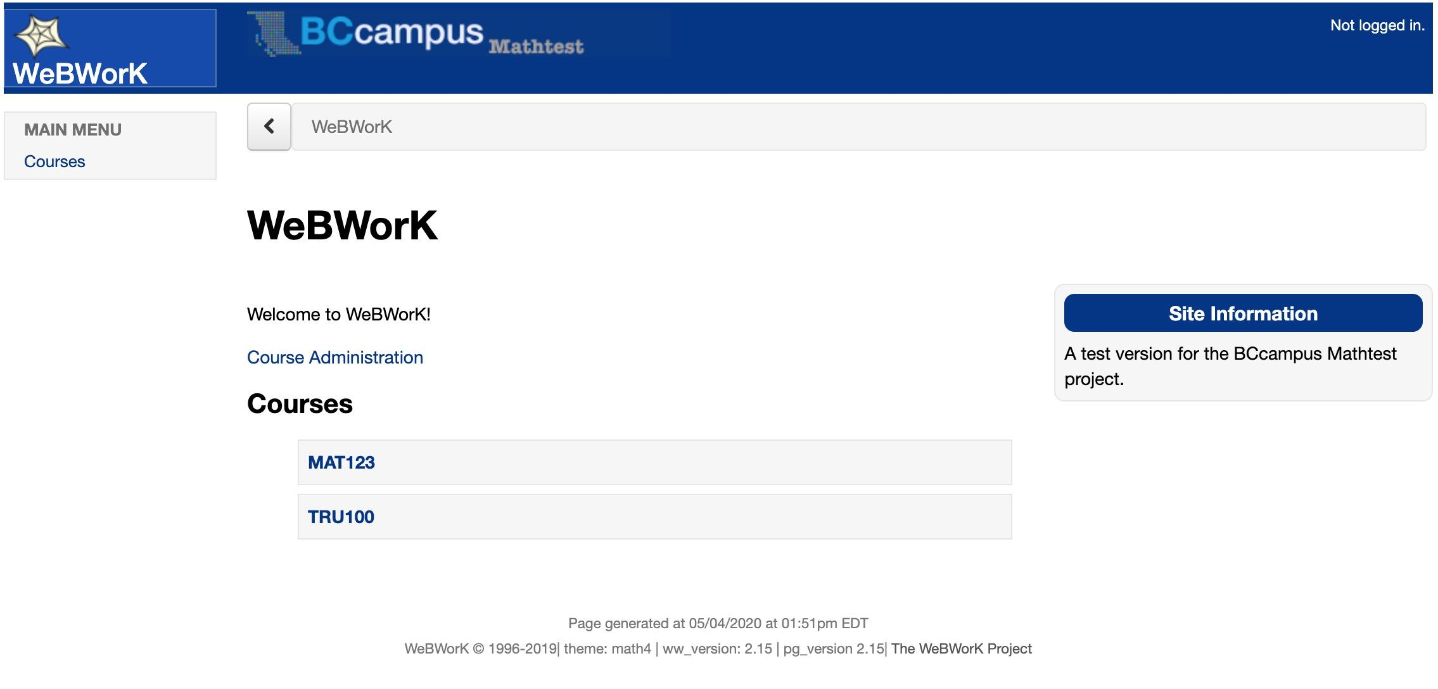
Here is the BCcampus Mathtest instance of WeBWorK.
Version 2.15 was installed following the scripted installation instructions from the WeBWorK wiki article Automatic Installation Script Guide.
WeBWorK runs under perl, which was already present in the Ubuntu server setup.
The application installation was run from within a web directory owned by the www-data group:
/var/www/html/app
Install WeBWorK using git:
sudo git clone https://github.com/openwebwork/ww_install.git
Then, navigate to /var/www/html/app/ww_install/bin to run the installer:
sudo perl ww_install.pl
This provides prompts for setup of a MySQL database, admin accounts, etc.
This first installation failed, due to a missing XML module:
Can't locate XML/Simple.pm in @INC (you may need to install the XML::Simple module) (@INC contains: /opt/webwork/pg/lib /opt/webwork/webwork2/lib /etc/perl /usr/local/lib/x86_64-linux-gnu/perl/5.22.1 /usr/local/share/perl/5.22.1 /usr/lib/x86_64-linux-gnu/perl5/5.22 /usr/share/perl5 /usr/lib/x86_64-linux-gnu/perl/5.22 /usr/share/perl/5.22 /usr/local/lib/site_perl . /etc/apache2) at /opt/webwork/webwork2/lib/WebworkClient.pm line 124.\nBEGIN failed—

compilation aborted at /opt/webwork/webwork2/lib/WebworkClient.pm line 124.\nCompilation failed in require at /opt/webwork/webwork2/lib/WeBWorK/ContentGenerator/instructorXMLHandler.pm line 38.\nBEGIN failed--compilation aborted at /opt/webwork/webwork2/lib/WeBWorK/ContentGenerator/instructorXMLHandler.pm line 38.\nCompilation failed in require at (eval 53) line 2.\nBEGIN failed--compilation aborted at /opt/webwork/webwork2/lib/WeBWorK.pm line 88.\nCompilation failed in require at /opt/webwork/webwork2/lib/Apache/WeBWorK.pm line 37.\nBEGIN failed--compilation aborted at /opt/webwork/webwork2/lib/Apache/WeBWorK.pm line 37.\n
This was addressed by trying an install of XML::Simple:
sudo apt-get install libxml-simple-perl
Running the installer script again picked up where it left off, but a second error was generated:
AH00526: Syntax error on line 12 of /etc/apache2/conf-enabled/webwork.conf:
Can't locate Email/Address/XS.pm in @INC (you may need to install the Email::Address::XS module) (@INC contains: /opt/webwork/pg/lib /opt/webwork/webwork2/lib /etc/perl /usr/local/lib/x86_64-linux-gnu/perl/5.22.1 /usr/local/share/perl/5.22.1 /usr/lib/x86_64-linux-gnu/perl5/5.22 /usr/share/perl5 /usr/lib/x86_64-linux-gnu/perl/5.22 /usr/share/perl/5.22 /usr/local/lib/site_perl . /etc/apache2) at /opt/webwork/webwork2/lib/WeBWorK/ContentGenerator/Instructor/SendMail.pm line 30.\nBEGIN failed--compilation aborted at /opt/webwork/webwork2/lib/WeBWorK/ContentGenerator/Instructor/SendMail.pm line 30.\nCompilation failed in require at (eval 335) line 2.\nBEGIN failed--compilation aborted at /opt/webwork/webwork2/lib/WeBWorK.pm line 88.\nCompilation failed in require at /opt/webwork/webwork2/lib/Apache/WeBWorK.pm line 37.\nBEGIN failed--compilation aborted at /opt/webwork/webwork2/lib/Apache/WeBWorK.pm line 37.\n
This required setting up cpanm to handle CPAN module installs, then using cpanm to install Email::Address::XS:
sudo cpan App::cpanminus
sudo cpanm Email::Address::XS

Following this, running the installer completed the installation of the BCcampus Mathtest instance of WeBWorK.

Management
Courses are created and managed via the site admin login. Each course is created with its own admin (typically, an instructor) with a separate login. Therefore, courses act independently of each other, each with its own interface to add and import users, assign roles, and create content.
Because we had a small number of users, Classlist Editor was used to create accounts or classlist files to import users into accounts.

Runtime Issues
After adding problems from the Open Problem Library (OPL) to a test course, this error was generated:
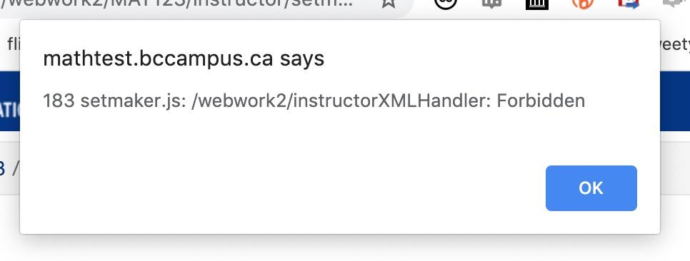
Checking the browser console revealed:
Failed to load resource: the server responded with a status of 404 (Not Found)
MathJax.js:1 Failed to load resource: the server responded with a status of 404 (Not Found)
/webwork2/instructorXMLHandler:1 Failed to load resource: the server responded with a status of 403 (Forbidden)

<script type="text/javascript" src="/webwork2_files/mathjax/MathJax.js?config=TeX-MML-AM_HTMLorMML-full"></script>
This indicated that MathJax had not been installed or was not in the correct directory. These steps in a WeBWorK forum thread about locating MathJax were followed to correct this issue.
Delete:
/opt/webwork/MathJax
Reinstall:
sudo git clone https://github.com/mathjax/MathJax.git

Check out the legacy version:
cd MathJax
sudo git checkout legacy-v2
Set owner/group permissions:
cd /opt/webwork
sudo chown MathJax wwadmin
sudo chgrp -R wwdata MathJax
This cleared up the MathJax issues.
But then server errors were generated while attempting to view a problem:

Warning messages
Couldn't find the OPL local statistics table. Did you download the latest OPL and run update-OPL-statistics.pl? at /opt/webwork/webwork2/lib/WeBWorK/Utils/LibraryStats.pm line 69.

Error messages
Table 'webwork.OPL_local_statistics' doesn't exist at /opt/webwork/webwork2/lib/WeBWorK/Utils/LibraryStats.pm line 71.
Information on OPL stats and updating (as well as using local versus global stats) were found on Geoff Goehle’s website.
Fixing this issue means running update scripts. Note that you should NOT do this via sudo, where you will not get the environmental variables (see this WeBWorK forum thread about problems with OPL-update).
First, make sure the account using sudo admin has privileges to write to server directories, and make sure the path is set:
export WEBWORK_ROOT=/opt/webwork/webwork2
Then:
perl /opt/webwork/webwork2/bin/update-OPL-statistics.pl
perl /opt/webwork/webwork2/bin/load-OPL-global-statistics.pl

SSL Update
If SSL was set up prior to installation, this step would be unnecessary. But since it was enabled later, these steps were needed to run WeBWorK under SSL.
Edit:
/opt/webwork/webwork2/conf/site.conf
To read:
$server_root_url = 'https://mathtest.bccampus.ca';

Importing Content into WeBWorK
The WeBWorK installer had the built-in option to install problems from the Open Problem Library, resulting in over 37,000 problems being available to all courses created on a site. The library interface provides filtering by math subject, chapter, and section. These can be imported into a WeBWorK course en masse or by selection.
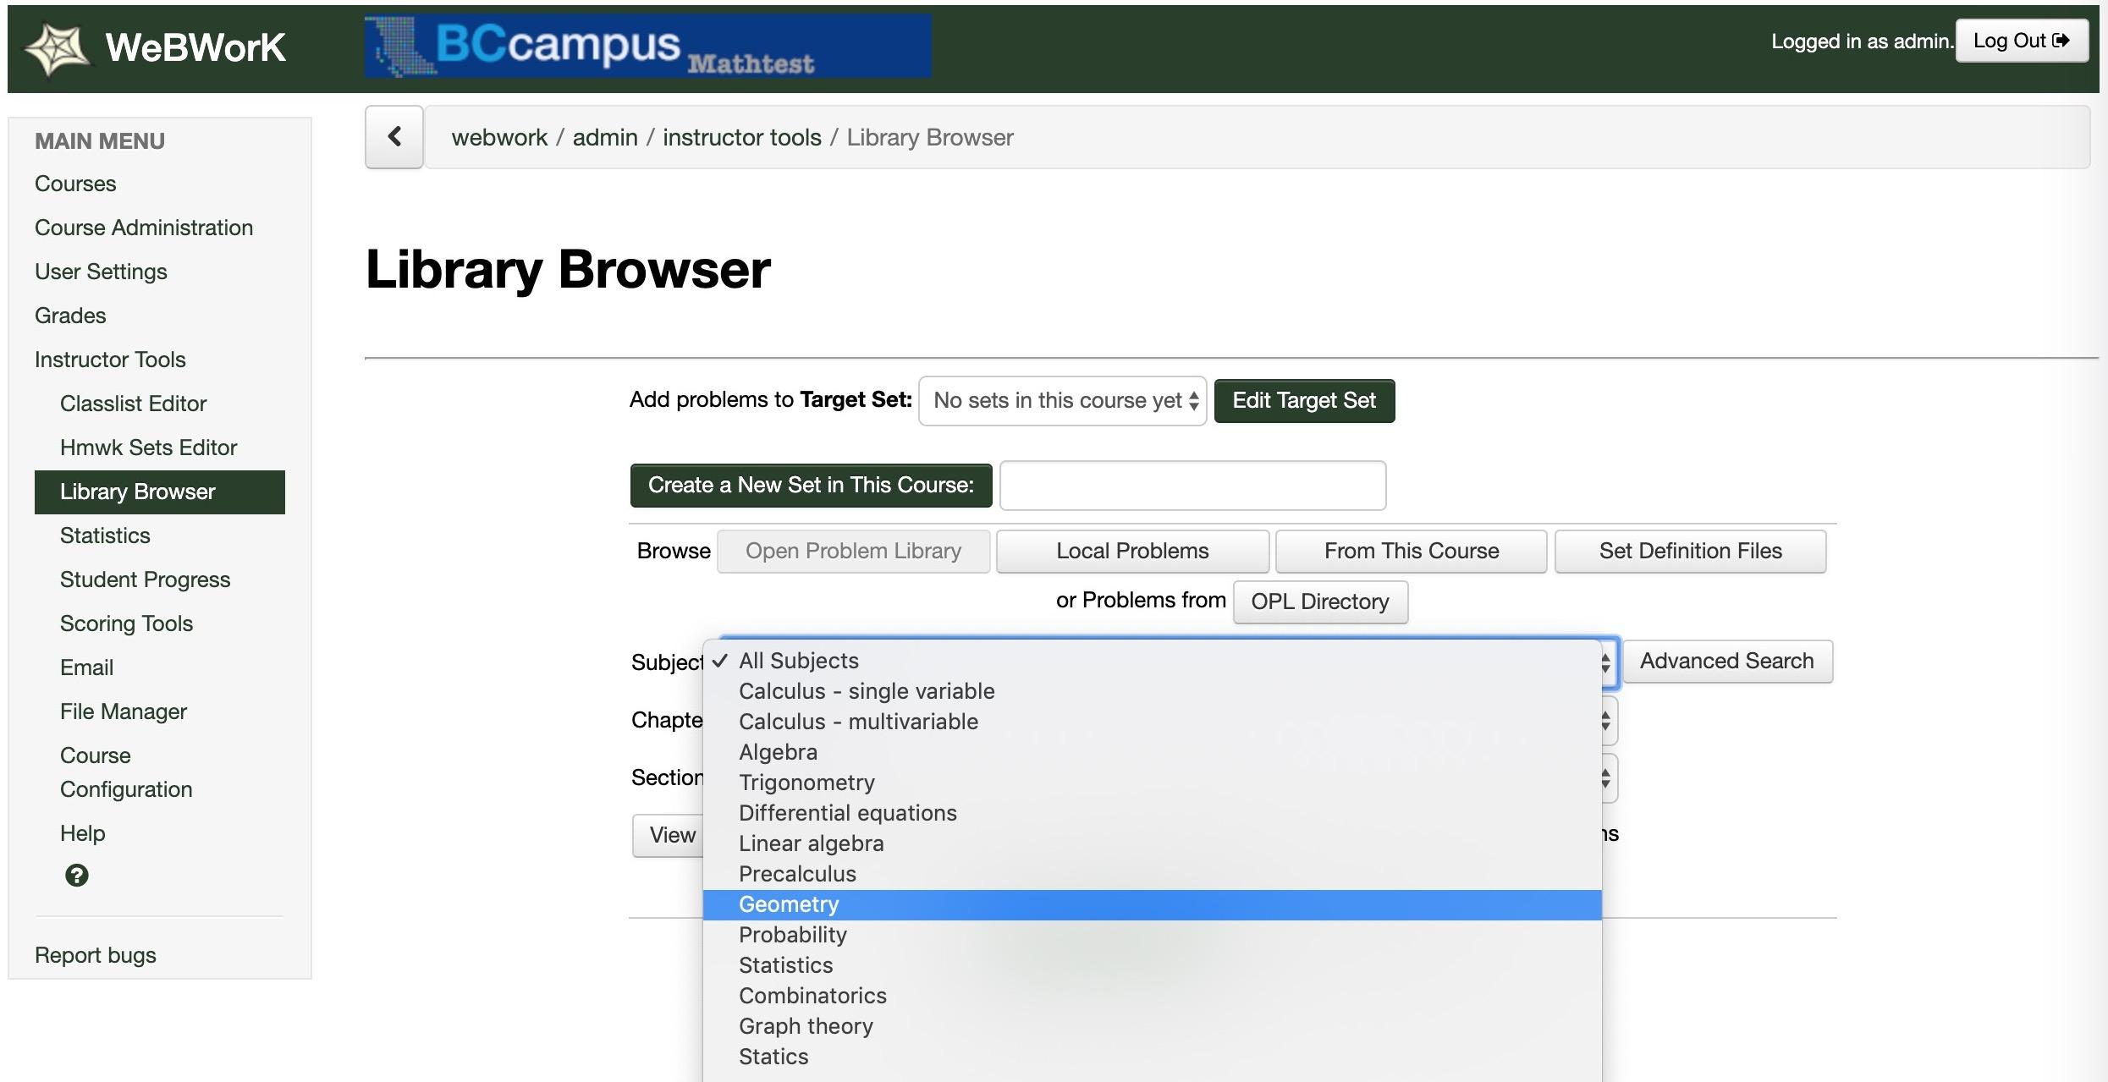

IMathAS Installation Notes
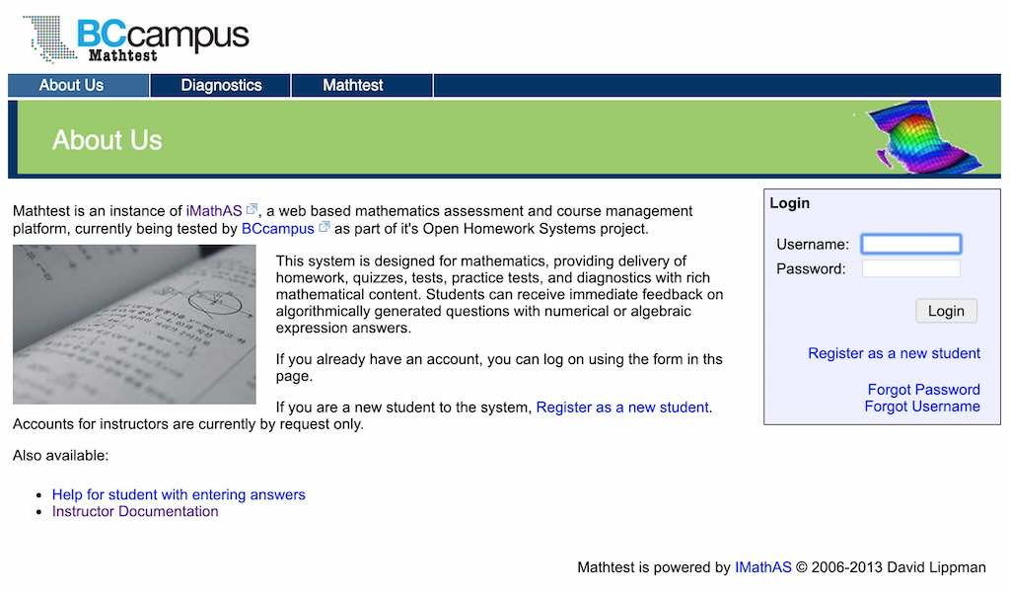
Here is the BCcampus Mathtest instance of IMathAS.

Initial Installation
Instructions followed from IMathAs developer David Lippman’s GitHub repository. We received a rapid response from Lippman (drlippman@yahoo.com) regarding a few issues.
At the time of installation, the recommended setup specified, “The system requires PHP 5 (7 recommended) with GD and FreeType, and MySQL 5.” As of the writing of this report, this has been changed to “The system requires PHP 7.1+ with GD and FreeType, and MySQL 5.”
Install GD:
sudo apt-get install php7.0-gd
Install FreeType*:
sudo apt-get install freetype*
The application was set up to run into directory /var/www/html/apps:
git clone https://github.com/drlippman/IMathAS
MySQL Database was set up via the command line, per the instructions.

On the first run of the BCcampus Mathtest IMathAS installation script, a permissions error was encountered:
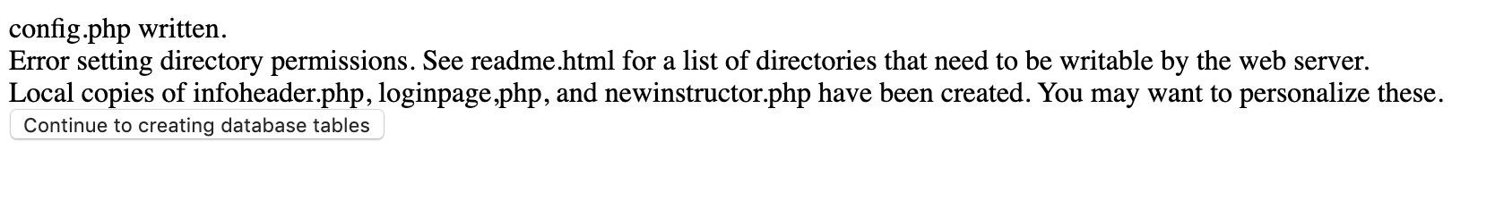
As noted in the installation instructions, permissions needed changes:
- /assessment/libsassessment/qimages Note: this directory does not exist! Changed permissions for /assessment/qimages
- /admin/import
- /course/files
- /filter/graph/imgs
- /filestore (if you're not using S3 for file storage)

Installing mimeTeX
mimeTeX appears to be needed as a math image fallback, but the instructions require a C compiler. For this site, I downloaded a compiled Linux version of mimeTeX [ZIP file], uploaded mimetex.cgi to the home directory, and set permissions to 755.
Tested successfully with:
./mimetex.cgi "x^2+y^2"
Then moved to cgi-bin and set permissions:
sudo cp mimetex.cgi /usr/lib/cgi-bin
sudo chmod 775 mimetex.cgi
The test mimeTeX command on BCcampus Mathtest works the same as in the mimeTeX page.

mb_string Required
Errors occurred on the first attempt to import course content. After exchange with the developer, he noted that mb_string functions needed to be added to the installation.
Installed via:
sudo apt-get install php7.0-mbstring

PHP Version Bumps
At the time of installation, PHP 7.0 was recommended, but on testing, errors occurred indicating a need for PHP nullable types, available in PHP 7.1, and the instructions now have this version as a requirement.

PHP was updated to 7.3 following the instructions in the article How to Install PHP 5.6, PHP 7.3 on Ubuntu 18.04 & 16.04 using PPA, seen here:
sudo add-apt-repository ppa:ondrej/php
sudo apt-get update
sudo apt-get install -y php7.3
sudo a2dismod php7.0
sudo a2enmod php7.3
sudo apt-get install php7.3-mysql
sudo apt-get install php7.3-mbstring
sudo service apache2 restart

Other Notes
- For broken pages (white screen), appending ?debug=true to the URL provides helpful diagnostic error messages.
- Make sure php.ini limits bumped from the default 2 MB, as this caused errors when trying to import larger content files.
- Permissions on IMathAS/infoheader.php and IMathAS/loginpage.php are set by default to 644; needed to change for group write permissions to edit templates for page layouts:
sudo chmod 664 infoheader.php
sudo chmod 664 loginpage.php
- IMathAS will use whatever protocol Apache is using, so no configuration changes when server was switched to SSL.

Importing Content into IMathAS
Content for several open courses provided directly by David Lippman were imported into the site:
Here are a few courses to get you started. I picked a few popular ones, and some well-done newer ones. Many of these are better than the ones mentioned on the page you referenced. If there are other particular courses you’d like, let me know.
You’ll import these by creating a blank course in your system, then using Course Items: Import to bring them in. I recommend enabling the “Use new assessment version” option under Additional Options when you create the blank course. Also, I recommend creating a question library (Questions: Libraries, then Add New Library) for each course, and tell the importer to put the questions in that library. That way, they'll live somewhere reasonable for now. Down the road, we can look into transferring question libraries with their structures, but this will give you a good start.

The courses added to the test site included:
- Applied Calculus (Calaway)
- Business Pre-Calc (Lippmann)
- Calculus 12 (OpenStax)
- Intermediate Algebra (OpenStax)
- Math in Society (Lippman)
- Precalculus (OpenStax)
- Precalc 1 (Lipmann + Rasmussen)
- Precalc 2 (Lipmann + Rasmussen)
- Precalculus (Stitz-Zeager)
- Statistics (OpenStax)
- Statistics (OpenIntro)

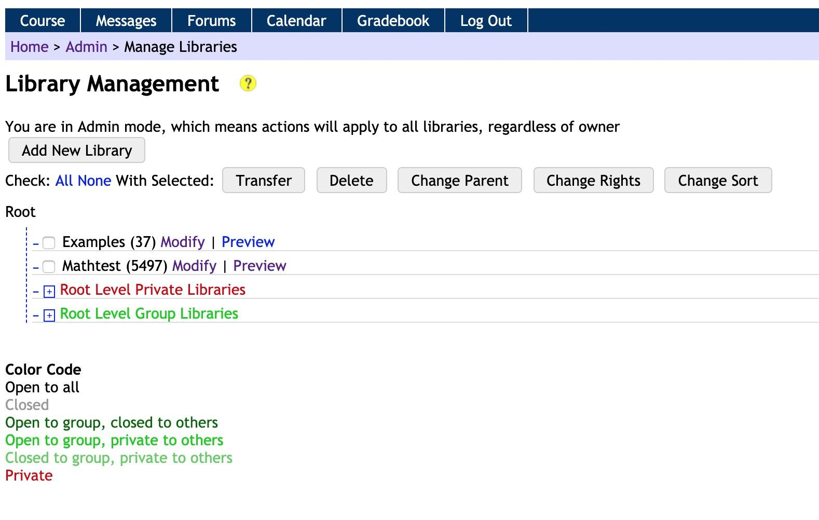
These appear as courses on the site. About 5,500 courses were added to a single Mathtest library. In hindsight, it would have worked much better to create a library for each course and make it easier for teachers and developers to browse at the course level, as there is not a search tool for the problems. The typical approach to course development appears to be to import an existing course, and then customize as needed within each course.

Numbas Installation Notes
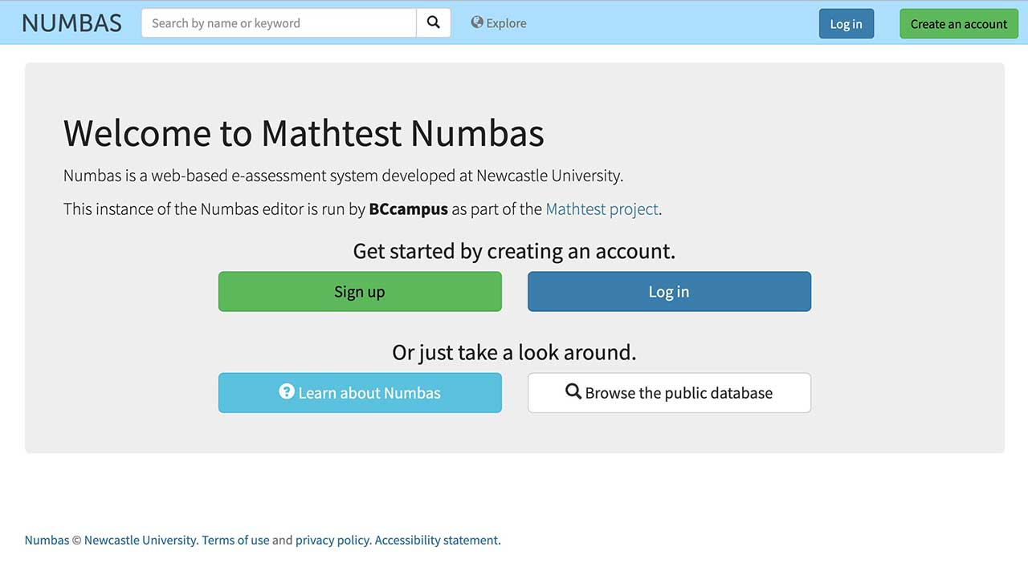

Here is the BCcampus Mathtest instance of Numbas.
Numbas was the most challenging of the three applications to get operational. Much help was provided by the lead developer, Christian Lawson-Perfect (christian.perfect@newcastle.ac.uk).
The installation was done via the instructions found in the article Installing the Numbas editor on Ubuntu, with modifications to step 1 because apache2 and mysql-server were already installed:
sudo apt-get install apache2-dev git-core \
mysql-common python3 acl libmysqlclient-dev python-dev \
libapache2-mod-wsgi-py3 python-tk tcl-dev tk-dev

Also, as it is not made abundantly clear, the server setup steps (1–4) need to be done via sudo, but all commands to the virtualenv (step 5) are done via an admin account, e.g.,
source /opt/python/numbas-editor/bin/activate
An error occurred running:
pip install mysqlclient mod_wsgi

Under step 3 of “Clone the editor and compiler repositories”:
/usr/bin/ld: cannot find -lssl
/usr/bin/ld: cannot find -lcrypto
collect2: error: ld returned 1 exit status
error: command 'x86_64-linux-gnu-gcc' failed with exit status 1
The solution is related to a missing library (see this Ask Ubuntu forum thread about the cannot find -lssl error) and was fixed via:
sudo apt-get install libssl-dev
For Numbas configuration on Ubuntu, first navigate to directory (not in docs):
cd /srv/www/numbas_editor
This would be much easier with access to root login. Many permissions needed to be changed (below) to run first_setup.py, as well as giving group ownership to www-data:
sudo chgrp -R www-data /srv/www/numbas_editor/numbas
sudo chmod 775 numbas
sudo chmod 775 web
sudo chmod 775 editor/templates
sudo chmod 775 /srv/numbas/static/
Other errors related to ownership were fixed via:
sudo chgrp -R www-data /opt/python
The site was now operational, but testing of previews of any item generated errors:
Traceback (most recent call last):
File "/srv/numbas/compiler/bin/numbas.py", line 33, in <module>
import jinja2
ImportError: No module named 'jinja2'
Fixed via:
source /opt/python/numbas-editor/bin/activate
cd /srv/numbas/compiler
pip install jinja2
Now getting an error 500 — a permission error on the jinja2 installs:
sudo chgrp -R www-data /opt/python/numbas-editor/lib/python3.5/site-packages/jinja2
sudo chgrp -R www-data /opt/python/numbas-editor/lib/python3.5/site-packages/Jinja2-2.10.3.dist-info

After many more attempts and submitting an issue with the developer, we found that the problem was that the software’s setup script used a wrong directory name by default (see this comment in a GitHub discussion about jinja2).
Success was achieved by changing the value of PREVIEW_URL in:
/srv/www/numbas-editor/numbas/settings.py
To read:
'PREVIEW_URL': 'http://numbas.mathtest.bccampus.ca/numbas-previews/',

Account Activation Error
Numbas was sending the wrong template and URL to activate new accounts (the URL ended with “example.com” rather than “numbas.mathtest.bccampus.ca”) and using the wrong email template. Filed a GitHub issue about the incorrect template and URL being used for account activation.
The answer was I needed to edit the Django sites for the BCcampus Mathtest instance of Numbas.
This resulted in another error. I had a video chat with the developer, and the ID number of this site (3) needed to be manually set here, because the site was added to Django rather than replacing the first site. The developer said this should not be hard coded, but it is.
/srv/www/numbas_editor/numbas/settings.py

Change:
SITE_ID = 1
To
SITE_ID = 3

Importing Content into Numbas
There is no feature to import large amounts of content into the Numbas editor: it is mostly the tool used to construct problems and sets (or exams). The approach for this project was to browse the public content from the Numbas website. The major public projects were browsed by math topic, and I exported as much exam content as was reasonable.
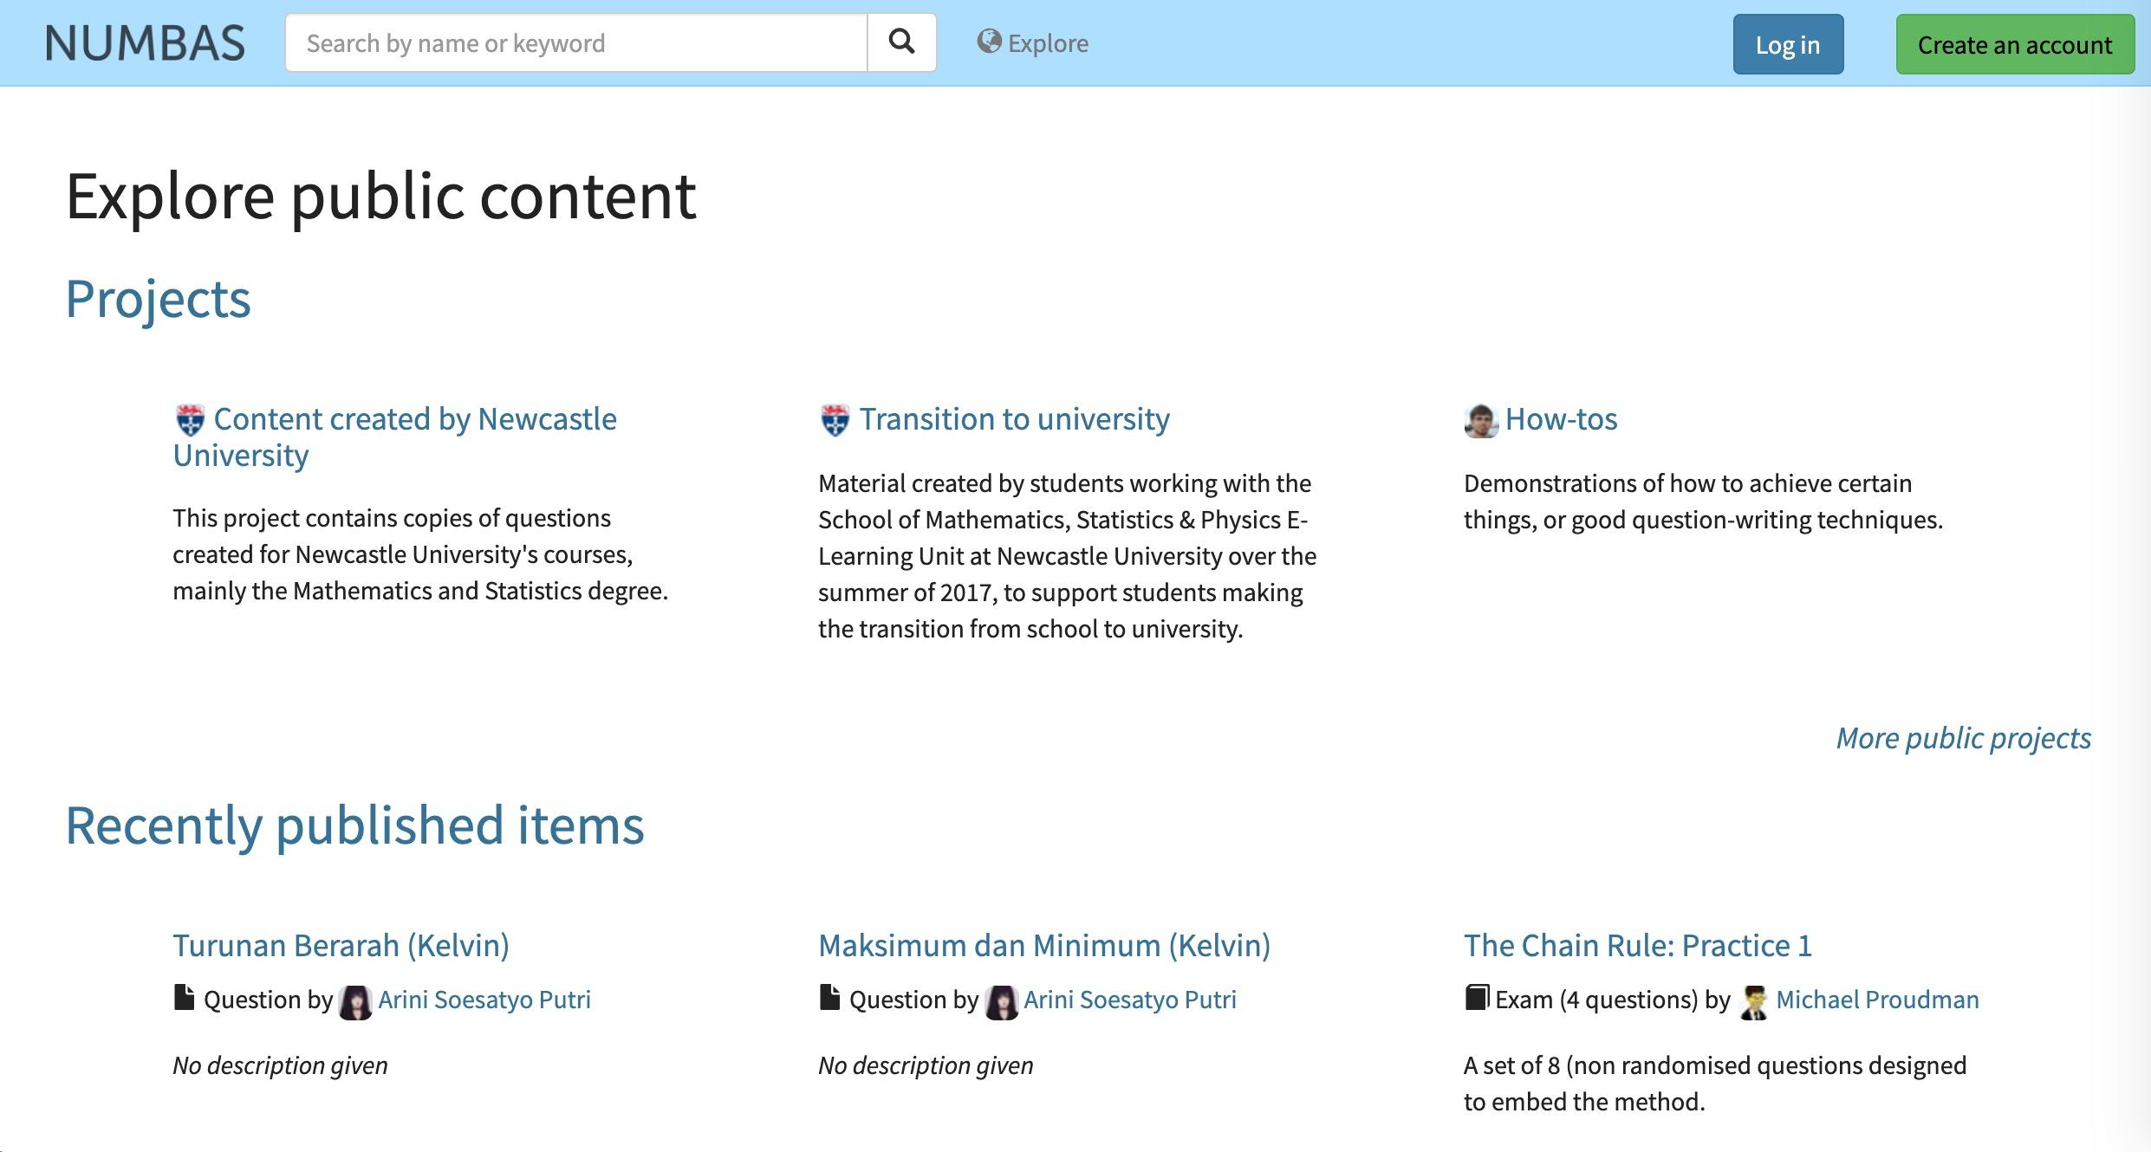
This content was imported into a few pre-organized projects on the test server for the project areas of calculus (166 problems and exams) and algebra (43 problems and exams), as well as a general project area for imported content from other subjects (157 problems and exams).
When I asked the Numbas developer if there was any way to import a larger library of content, he replied:
There isn’t a way to export in bulk at the moment. I wouldn’t recommend it, either: you’d just end up with a snapshot of the exported content at a moment in time, and when you come round to use it, you might have missed out on changes made by the original author.
Any shared hosted version of the editor would then need a good number of active users to create and modify content. I was also told that very few people had installed the editor as we had done (it was provided because it was for an open source project), and that its intent is mainly to provide a central service from the Newcastle University server.

Notes on Integration
The scope of this project did not include fully testing the LMS integration potential for these platforms. The summary below is gleaned from the available documentation for each.

WeBWorK Integration
WeBWorK includes module LTI integration and documentation with configuration details (passing LTI key and LTI consumer secret, and base URL for WeBWorK instance) for Blackboard, Canvas, Moodle, and D2L (see LTI-Advanced Authentication on the WeBWorK wiki). This requires admin access to the LMS to set up.
Each LMS needs custom edits to enable adding links to the WeBWorK instance. Fairly good basic instructions for doing this in Blackboard, Moodle, and Canvas are available (see Adding Links to WeBWorK in the previous article). As noted, “Be aware that each LMS has its own quirks and possibilities.”
WeBWorK is designed to automatically create accounts for students who access WeBWorK via the LTI integration. The article linked mentions considerations for cases in which students may get access to change their passwords if they access WeBWorK outside of the LMS as well as setting up for campus-based LDAP authentication.
The documentation for LTI-Advanced Grading in WeBWorK outlines how WeBWorK may be configured to pass back grades to the LMS. It offers two modes, the simplest of which is a Course Grade Mode, in which WeBWorK returns a single grade representing a percentage of all work completed there. The other option is to set up Homework Grade Mode, which allows WeBWorK to return a grade column score for each problem set.
This appears to be set across the system, so all courses using WeBWorK would use the same mode for grade passing. It’s also worth noting that, when integrating WeBWorK with an LMS, problem set availability should be managed by WeBWorK: “It is recommended that you do not set due dates in the LMS and allow WeBWorK to control the availability of the problem sets.”
There appears to be more integration potential with Moodle, though it appears that these approaches pre-date the availability of LTI. This includes an ability to integrate a WeBWorK Moodle Assignment module that reportedly works well for large classes. And finally, there is a means (see Moodle Question Type in the WeBWorK wiki) to assign WeBWorK problems within Moodle quizzes: “From the perspective of a user who is new to WeBWorK or already comfortable with Moodle, this is the recommended application for integration with WeBWorK.”

IMathAS Integration
IMathAS LTI integration can be established at the administrative level (across an installation, but also enabled system-wide or per the group permissions). It appears that an installation can be set up for instructors to create an integration at the course level, too. IMathAS states compatibility with LTI 1.1.
More details of capability might be gleaned from the LTI settings in the IMathAS source code.
The instructions are very basic and do not seem to provide LMS-specific instructions, although the developer has produced videos demonstrating IMathAS integration with Canvas [video] and IMathAS integration with Blackboard [video] (as of 2018). There are also more LMS-specific details provided by MyOpenMath.

Numbas Integration
LTI integration is essential for Numbas, as unlike WeBWorK and IMathAS, Numbas does not provide a means of managing problem sets assigned to students; it is purely a questions and exam creation platform. Numbas-created exams may be viewed only on a site running the editor; there is no ability to send students there to get assessed.
Numbas does provide a SCORM export, allowing authored exams to be imported to an LMS, but then these become static to the version at the time of export. Numbas seems more aimed toward being a live content source via the LTI mechanism.
Both means are available when the LTI connection is established:
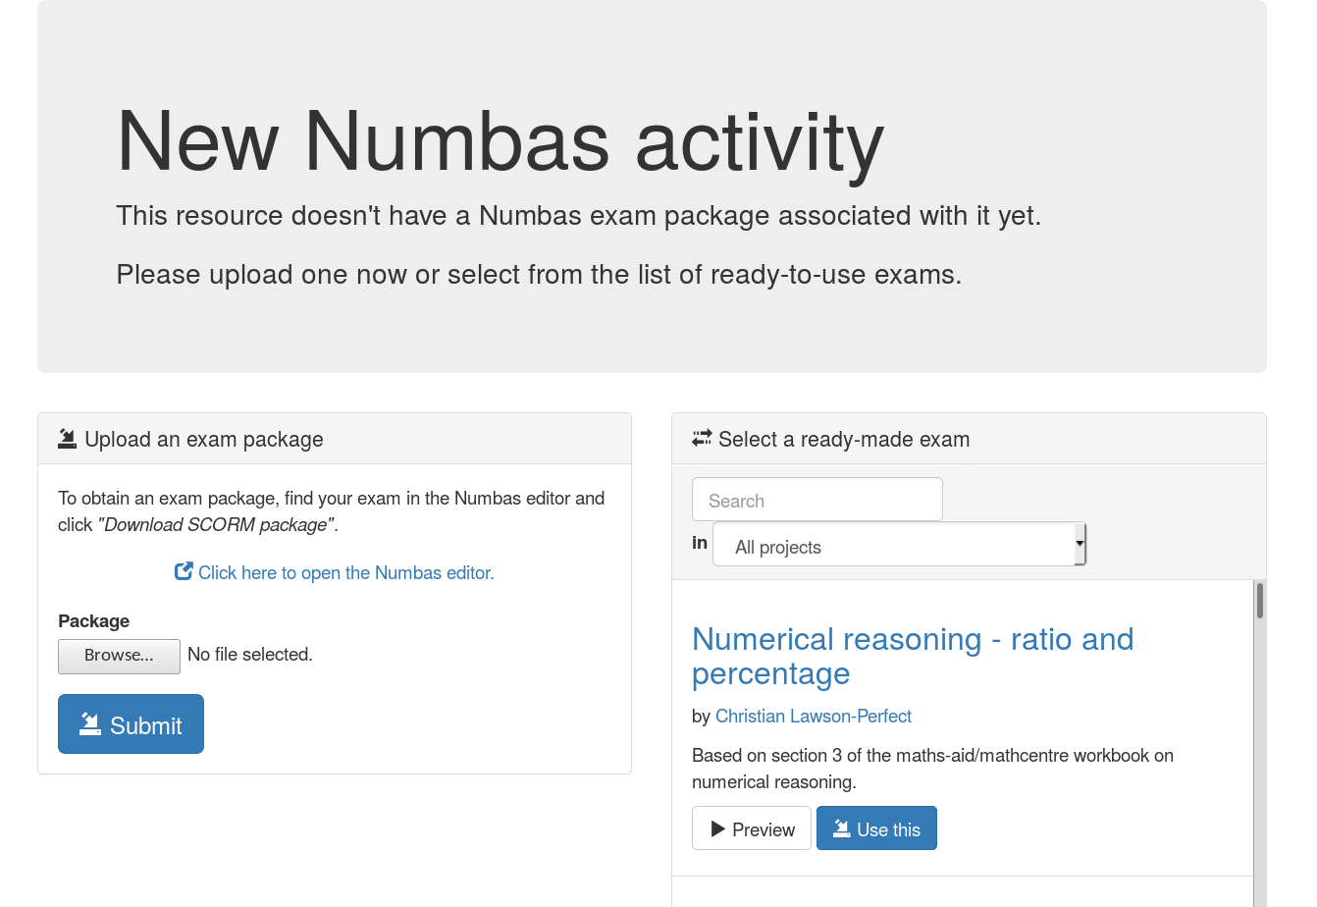

A very complete set of documentation for LTI integration with Numbas is available online. It provides explicit instructions for setting up Blackboard, Moodle, and Canvas as a consumer from a Numbas exam editor site. Note that this provides the LMS with access to all projects in a Numbas site that are made publicly available, thus making available in the LMS all exams within that project.
Numbas appears to offer a versatile set of scoring mechanisms: data is available for attempts at problems, not just raw scoring. Data can be reported back to an LMS, or downloaded as CSV or JSON data files. An interesting feature is the ability for an instructor to discount part of an exam (remove something from scoring) if an issue is discovered after the exam has been put into use.

Summary Notes
This testing was focused mostly on getting the three software systems operational; less reviewing was done of specific administrative features. Below are a few reflections on the interfaces and systems as experienced in this testing period.
WeBWorK is very sophisticated and has a very active user community (see the Using WeBWorK forum), as well as a developer network that is active in supporting and adding features. It was certainly the most robust with available content. A valuable feature for admins and instructors within a course is the ability to view WeBWorK as a particular student. A most useful resource for instructors is A Day in the Life of A WeBWorK2 Professor. WeBWorK is aimed at helping instructions build their own exams from its large bank of existing content. Problem authoring is very technical, requiring its script-like macro language and MathObjects. It’s unlikely too many instructors would need to program these from scratch, as there are sufficient ones that can be modified as needed. It was not too challenging to install.
IMathAS offers on its own an almost LMS-like experience, which makes it worth considering as both a standalone system and as something integrated into other LMSs. Its adoption into several platforms, such as MyOpenMath, suggests it is a most reliable and scalable system. Its usage in alignment with existing open math textbooks is a compelling feature, too. Writing questions in IMathAS is a very technical process that is unlikely to be something that most instructors would take on, but worth seeing is A Programmer's Guide to MyOpenMath [PDF], a presentation by Joseph Manthey at the NEMATYC 2018 conference. There does not seem to be a large developer community for IMathAS, but David Lippman is extremely responsive to issues submitted to the IMathAS source code repository. Beyond some PHP version issues, installation of IMathAS was smooth. Creating a large set of problems on the scale of WeBWorK might not be feasible, but a good number of problems were made available from the open source textbooks shared by the developer.
Numbas was the most challenging application to install. Anyone who wishes to install it would benefit from experience with Python and Django configuration. It has the most modern interface of the three apps, and more of a wizard-like process for constructing questions and exams. It’s difficult to compare as, unlike the other two tested systems, it is not independently a math assessment platform, but more of one to create the practice problems that would need to be loaded into an LMS. There was no ability to import a library of content like the other two systems. Numbas would perhaps be effective in a supported environment where content was being created collaboratively by a number of developers and instructors.

