Math Homework Platform Testing

Shirin Boroushaki
Department of Mathematics and Statistics
Thompson Rivers University
Date: May 2020

Table of Contents

Introduction 3
Attractive Features of Each Platform 4
WeBWorK 4
IMathAS 4
Numbas 4
Question Authoring 5
IMathAS 5
WeBWorK 5
Numbas 6
Comparison of the Three Platforms 6
Problem Library 9
IMathAS vs. WeBWorK 9
Numbas 10
Class Management and Analytic Tools 11
WeBWorK vs. IMathAS 11
Numbas 12
Question Randomization 13
Feedback Options 13
IMathAS vs. WeBWorK 13
Student Experience 14
Colleague 1 14
Colleague 2 14
Conclusion 15

Introduction
The purpose of this document is to report on the testing done on three open source homework systems. These systems are primarily used in math and are as follows:
- WeBWorK, which is primarily a math assessment tool purposed for online homework or tests and their automatic grading.
- IMathAS, which is also designed for online delivery of homework. It has additional capabilities similar to a learning management system (LMS), which allows uploading files and videos and posting announcements. It provides a full gradebook as well.
- Numbas, which is mainly designed for authoring online assessments, therefore, its main users are meant to be question authors and course instructors. The content created in this platform should be exported to and delivered via a virtual learning environment.
Each platform has been tested and analyzed according to the primary deliverables of the project. In the following sections, the different features of the three platforms are compared.

Attractive Features of Each Platform

WeBWorK
The magnitude of the WeBWorK Open Problem Library (OPL) is certainly one of its distinctive features. WeBWorK’s large number of users and the fact that several institutions contribute to the OPL with the approval of the library’s reviewers signify the quality of the question bank.
The extent and availability of documentation and help resources addressing a variety of questions about different components and features of WeBWorK are notable. In addition to the official documentation on the Mathematical Association of America (MAA) website and comprehensive wiki help pages, there are a large number of videos, tutorials, and help resources available online posted by the platform’s many users.

IMathAS
The fact that the majority of math problems in IMathAS are paired with links to tutorial videos is its most significant educational feature, in my opinion. While doing their homework, students often use online videos to get answers to their math questions; having these videos available alongside a homework question serves well to provide instant help.
One other useful feature of IMathAS is its link with open textbooks. This is particularly valuable to first-year calculus courses (and some second-year courses, too), in which the content is, to a large extent, universal, and different textbooks do not offer significantly different content. Having an open textbook tied with an open homework platform in one place is a convenient and certainly affordable tool for students.
The fact that IMathAS provides an LMS environment gives both the instructor and students more flexibility in working with the system and communicating with one another. Capabilities such as group assessments, forum discussions, and feedback options are some of the useful features to mention.

Numbas
Given that Numbas is primarily designed for question authoring rather than homework delivery, there is not much to compare with the other two platforms.
However, within the scope of the system, one can appreciate the ease of uploading a Numbas-created assignment set to an LMS (learning management system). Following the website’s instructions, I could download the SCORM package corresponding to a created assignment and upload it to a Moodle course, where the imported assignment ran smoothly. Another feature mentioned on the Numbas website that sounds interesting is the option to deliver homework offline through a DVD or USB stick. Unfortunately, the link directing to instructions on how to implement this feature was not working, so I could not test it out.

Question Authoring
Based on my experience, question authoring, in all three platforms, requires some level of expertise and knowledge in coding languages. Hence, many math instructors are not inclined to get involved in this aspect of online homework systems.
I created three questions on each platform. My general observation was that, in all three platforms, it would take a person with minimal knowledge of coding a considerable amount of time to find useful and relevant information in the documentation, read a piece of existing code, and understand how and where to manipulate the code to create a new question.
It was, nonetheless, relatively easier to find help files for authoring questions in WeBWorK than in the other two platforms. On the other hand, with more exposure to each system, one could gain more understanding of the coding components and, consequently, more confidence and progress in writing questions.

IMathAS
IMathAS uses PHP programming language for writing questions. Once an assignment is created, one can choose the Add New Question option to create a new problem in the assignment set. This option opens the question editor page, which consists of different components corresponding to different steps in authoring a question, such as Description, Rights, Question Type, Question Control, and Answer. There are twenty question types, including Number, Multiple Choice, Multipart, Matching, Function, and Interval. To create a question of a particular type, it is easier to import an existing question of the same type and modify the code to create a new question instead of writing an entirely new question, which is what I did.
The documentation provides help for each step of writing a question. There is also a link to Macro Library Help in the editor. Personally, I needed to refer to an existing question to create a new one; the documentation by itself was not sufficient.

WeBWorK
WeBWorK uses the Perl programming language for writing questions. One can create a question in WeBWorK in two ways. The first way is to use the built-in WeBWorK editor, in which one can either write an entire question or copy existing code into the editor and make necessary modifications to create a new question. Similar to IMathAS, each question is categorized by its type. One can import an existing question of a desired type and modify it in order to create a new question of the same type.
Another method for creating new questions in WeBWorK is to code the question in a local text editor, upload it to the WeBWorK file manager as a text file, and then save it on the WeBWorK server. Question files located in Templates in the WeBWorK file manager can be used in a course.
I used the first method described here to create three questions on WeBWorK. I copied existing code into a local text editor, modified it, and pasted it into the WeBWorK editor. Then, I saved and appended the newly created question to an assignment set.

Numbas
Numbas, mainly a question authoring platform, looks quite different than the other two platforms. Once the user begins to create a question, the question is then split into several components: Statement, Parts, Variables, Advice, etc. Each of these components is presented as a tab, which, upon being clicked, will open a separate window containing the editor for the selected component. Therefore, not all components and their editors are viewable at once in the same window.
To my understanding, the Numbas interface is devised in such a way that one can author a question with minimal coding knowledge. For instance, there are drop-down menus in which the author can select the data type when defining variables rather than writing the actual command. However, depending on the question complexity, there is still a noticeable need for more coding options, which I believe is covered by the JME code option provided in the drop-down menu, which I did not try.

Comparison of the Three Platforms
I rank Numbas the lowest in terms of usability and ease of working with the question editor. The fact that the editors for different components of a question have to be opened separately, and one cannot view the full code altogether, makes it harder to work with. During the process of writing a question, I had to frequently hop from one editing page to another, because modifying one component of a question had affected the other components, so I had to make necessary changes. It would be easier if one could see and modify all components on one page.
Between IMathAS and WeBWorK, the coding knowledge required was not significantly different, from my perspective as an unskillful coder. Regarding the equation editor, I am slightly leaning toward WeBWorK. In both platforms, one considers certain components — such as Description, Owner, Library, Question Statement, and Answer — to include in the code. In IMathAS, these components have their separate sections, which sometimes confused me. Occasionally, I wondered what should be written in Common Control and what in Question Text, for instance. In contrast, WeBWorK has one space for writing the entire question, including all the corresponding components. However, there is the Tutorial Style Editor feature in IMathAS editor that may make coding easier. This is an alternative to the regular editor for Multiple Choice, Numeric, Algebraic, and Essay type questions, where there are drop-down menus for choices and question marks.
The breadth and availability of existing documentation and help resources for authoring questions in WeBWorK is noteworthy compared to the other platforms. There are various types of references — including text files, sample code, and videos — accessible to WeBWorK question authors. In addition, one can find sample code sorted either by math subject, problem technique, or question type. This makes it convenient for the user to find help in a certain area.
All three platforms cover almost all common question types that are typically used in math assessment. Nevertheless, the WeBWorK list of question types is far more detailed, with a more specific and narrowed-down classification of various question types.
Below are sets of screenshots of question editor pages in each platform. The picture on the left is the blank editor page, and the one on the right is the editor containing sample code for a question. The pictures are taken from IMathAS, WeBWorK, and Numbas, respectively.

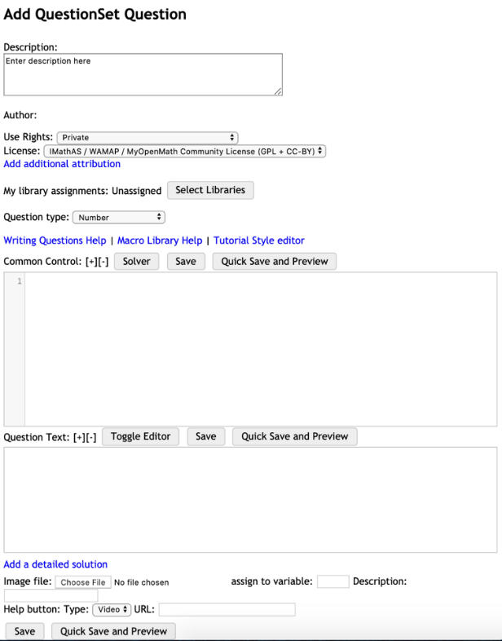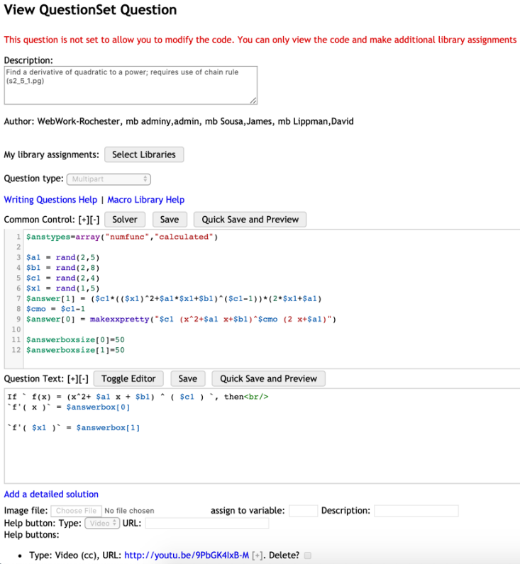
Figure 1 iMathAS
The IMathAS editor page has separate boxes for different components of the question, whereas, in WeBWorK, there is one single editor box for the entire question code. In WeBWorK, question components are determined by inputting system commands and codes in a certain order.
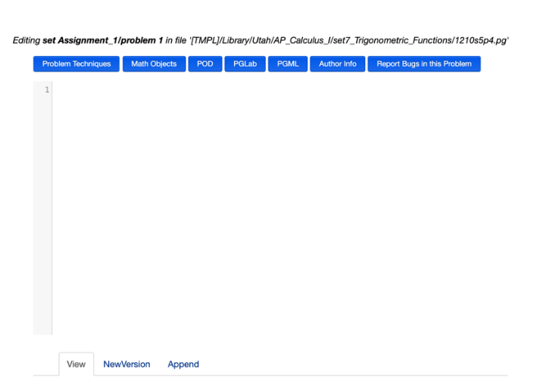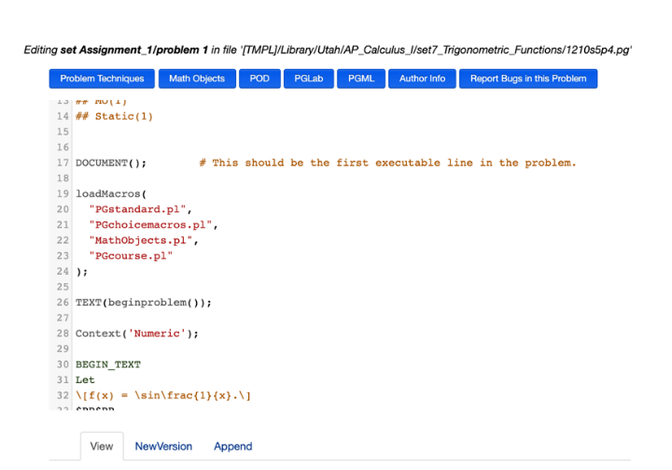
Figure 2 WeBWorK
Numbas, however, has a different style for question authoring. Each component of the question is presented as a tab on the left-hand side of the page, appearing as Statement, Parts, Variable, etc. To write a question, one has to navigate through these tabs, viewable in separate pages.

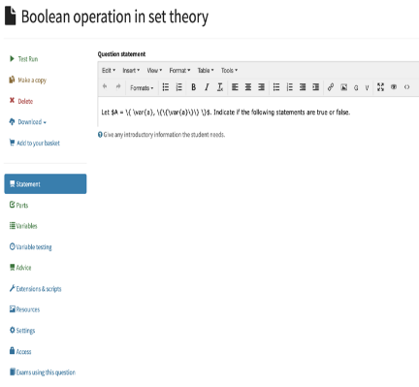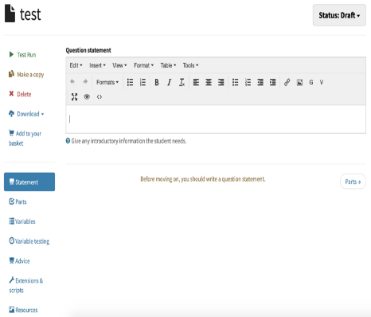
Figure 3 Numbas

Problem Library

IMathAS vs. WeBWorK
The BCcampus Mathtest instance of IMathAS organized its problem library differently than the actual library on the IMathAS website. The imported library was organized according to a subset of online courses that were offered through the IMathAS system; hence, homework problems had to be copied from the assignments used in those courses. In order to evaluate the actual library and problem classifications, I created a separate account on the IMathAS website.
Both the IMathAS and WeBWorK problem libraries are sorted by major university-level math topics, then each topic is divided into subtopics covering the most common syllabi. The libraries include typical first- and second-year math courses, such as calculus 1 and 2, linear algebra, and differential equations. There are also a number of non-math libraries in both platforms, whose size and extent differ in IMathAS and WeBWorK, respectively. They include subjects such as statistics, physics, and finance. Since the content in IMathAS is partly tied with open textbooks, there is a folder in the library called Textbook Specific, which is a collection of homework problems from different open textbooks.
The WeBWorK open library covers homework problems suitable for all typical first- and second-year math courses. The subject calculus on WeBWorK includes about 8,500 problems, compared to about 5,000 in IMathAS. Second-year math courses — such as differential equations and multivariable calculus — have almost an equal number of problems in both platforms, while in linear algebra, WeBWorK has almost three times the number of problems as IMathAS. On the other hand, IMathAS has about seven times more problems than WeBWorK in statistics. In IMathAS, there is also a library named Math for Elementary School Teachers, which has no counterpart in WeBWorK.
In addition to WeBWorK’s extensive problem library for classic university-level math subjects, it covers some higher-level math topics usually offered in the third and fourth year of an undergraduate program. These subjects are missing from the IMathAS library. However, one should note that the number, variety, and range of WeBWorK problems for higher-level subjects is significantly less than for lower-level ones. Arguably, the homework philosophy in advanced math courses is founded on essay-type questions, where students need to practice their math writing skills, hence an online homework system is usually of secondary importance in these topics.
Regarding non-math subjects, the WeBWorK library includes several subjects in physics, one subject listed as Operations Research, a set for statistics, and a set for financial mathematics. The size and extent of pre-built non-math libraries in IMathAS is comparably larger, as it has libraries for chemistry, accounting, and astronomy, and a more inclusive library in physics.
To sum up, one can claim that existing libraries in both WeBWorK and IMathAS are sufficient to cover maths and stats in lower-level university courses. However, WeBWorK can better serve online delivery of homework for higher-level math subjects, whereas IMathAS includes reasonably broader libraries of problems with respect to non-math subjects.

Numbas
The library imported for testing purposes included a very limited number of topics, with several questions incomplete and not ready for use. I am not sure why, but for some reason, I was not able to access the full library of existing questions on Numbas. Therefore, I did not evaluate the actual library of existing questions.

Class Management and Analytic Tools

WeBWorK vs. IMathAS
The class management and analytic tools in both WeBWorK and IMathAS are quite similar, with a slightly different format in data presentation. The Classlist Editor page in WeBWorK and the Roster page in IMathAS each provide a list of users and their personal account information. Both pages give instructors tools to:
- Manually add one or multiple students, assign login IDs and passwords to them, or add a large number of students to a course by importing a class list. The imported list must be in a specific format.
- Export a list of users. In WeBWorK, the list is exported to the WeBWorK file manager, where it can be downloaded and converted to an Excel spreadsheet. In IMathAS, the list is accessible through a link to a CSV file.
- Filter, sort, edit, drop, and delete an individual or a group of users.
The Homework Sets Editor page in WeBWorK provides tools to change individual or group settings for each homework set in a course. The actions possible with these tools include the following:
- Create or delete a set of assignments.
- Edit the opening and closing dates of a set, the visibility of a set to students, and the type of the assignment (homework or quiz), either for the whole class or particular student(s).
- Edit the setting for each question in a homework set. One can mark the question as correct, change the number of attempts and the weight of a question, change the order of questions, and edit the code for a question. These changes can be made for the entire class or for an individual version of a homework set.
To check and analyze individual or class performance in an assignment set, one can use Statistics or Student Progress pages on WeBWorK. One can choose to view statistics for a homework set assigned to the entire class or view individual performance in an assignment. On the page View statistics by set, one can find charts with information about:
- The percentage of the class with correct answers in each problem.
- The average number of attempts for each question.
- The percentage of students receiving a certain score.
The percentile cut-offs for the number of attempts for each question.

One has also the option of viewing statistics by student to check:
- An individual’s raw score and percentage score in each assignment set and their total grade in all course assignments.
- An individual’s grade in each question in the set and the number of attempts they made until they achieved the correct answer.
- An individual version of an assignment set with random parameters as they appear specifically for that version. Using this option, the instructor will be Acting as a certain student in the course.
The Student Progress page gives similar analytical opportunities as Statistics, with assignment set view and individual view of the progress in each assignment.
One can view and export a compiled record of class performance in one or all assignments using the Scoring Tool option. One or more of the assignment sets can be selected to be stored in a CSV file for download.
The analogous options in IMathAS regarding information about students’ grades, their performance in each assignment, and their overall grade are available through the Gradebook page. However, since IMathAS operates as an LMS, it provides the instructor with additional features regarding users’ activity in the system. Given a specific time window, one can view an individual’s full login and activity log in IMathAS. Moreover, IMathAS gradebook has the capacity to insert additional grading categories besides the default category, manage the weight of each category, and specify a certain number of lowest scores to be dropped by the system when calculating the total grade. Another additional feature in IMathAS is the option to add comments in the gradebook for an individual student.
WeBWorK, on the other hand, provides a more detailed statistical analysis of the data regarding students’ performance in each assignment. WeBWorK illustrates comprehensive question-by-question charts on how the entire class performed in each problem in a homework set and their average number of tries in each question. I believe this feature is particularly effective in giving instructors some insight into common misconceptions in their classes, thus allowing them to act upon that information.

Numbas
Class management and analytical tools do not apply to this platform, due to its divergent nature from the other two platforms. The online assessments in Numbas are to be incorporated into and accessed through an LMS; therefore, the class list and gradebook options are controlled by the target LMS. I should mention that I uploaded the SCORM package of Numbas-created homework to a Moodle course: for each imported homework task, Moodle created a column in the gradebook. The homework is auto-graded and grades are saved in the Moodle gradebook.

Question Randomization
All three platforms have options to generate a question with random parameters. In WeBWorK and IMathAS, randomization is done through the randomizers used in Perl and PHP, respectively. There are a variety of randomizers to produce a single numeric value or a list of random parameters. In Numbas, in the variable definition step, the Data type drop-down menu provides two options: generate a single random number, or a list of random numbers from a given range with a given step size. In case additional randomizers are required in writing a question, one can select the JME code from the drop-down menu and write the JME function to call the desired randomizers.

Feedback Options

IMathAS vs. WeBWorK
In terms of technical instructions and feedback on how to use the system, both platforms include tutorial-like questions and some demonstrations to instruct students on how to enter different types of answers. For questions that require a certain format for the answer or special characters, there are instructions in the question statement about that, and in case the entered answer does not match the format, a message will be shown indicating the formatting error.
IMathAS has the helpful feature of providing the user with a list of math functions and characters needed for a question once they attempt to answer that question. Instead of typing the entire math syntax, the user can select the appropriate math-type functions to be entered in the answer box. WeBWorK has no such feature; the syntax for the answer must all be entered by the user, although the Preview My Answer button in WeBWorK checks and displays the syntax formatted.
In both platforms, each problem in a homework set is accompanied by an Email Instructor or Message Instructor button. Students can use this option to contact their instructor or TA and ask about the homework. In WeBWorK, though, the email generated by the system and sent to instructors contains detailed information indicating the homework set to which the question belongs, the question number, and a link to the actual question. The link will show the instructor the version of the question assigned to the user who has sent the feedback.
In both platforms, the majority of problems do not include a full solution or hints; they only reveal the final answer. However, one can add a full solution to an existing problem by modifying its code. IMathAS offers certain additional features for assisting students to solve a problem if they have unsuccessful initial attempts. Each problem comes with a Try a similar problem button that becomes visible after the first unsuccessful attempt, which generates a similar problem with different random parameters in equations. The instructor can choose to deactivate this option in question settings. Moreover, in the majority of existing libraries in IMathAS, each math problem is linked to a tutorial video explaining the concept(s) tested in that problem or solving a similar problem.
In IMathAS, the instructor is also able to create forum pages for different purposes in the course, so that students can communicate with the instructor or a TA coordinator and also have discussions among themselves.

Student Experience
I added two of my colleagues to IMathAS and WeBWorK in student roles and assigned them homework sets in each platform. Here are their opinions on each platform:

Colleague 1
WeBWorK doesn’t have a Math Editor where a student can click on templates. I had to use ^ signs and lots of brackets, and I could see where students might be challenged to get the details right so that they have entered in exactly what they’ve intended to. I imagine that that could be frustrating, particularly early in the term, though they should be able to acclimate to it after a while (and they might learn something through the process). The “preview answer” feature would re-write their answers in the standard mathematical symbols, allowing them the chance to check how it looks before they submit their work for marking (and being given multiple attempts would help ease their frustration as well). IMathAS was a little easier to enter in, as you could click icons that did the math notation.

Colleague 2
I found IMathAS more user-friendly for typing math because of the Equation Editor. However, in WeBWorK, there is a link to a page introducing some mathematical notations. Also, in WeBWorK, Preview My Answers is useful when working on a problem set. The hardcopy generator is a great tool in WeBWorK to have a summary of the questions and answers along with the hints and correct answers. IMathAS and WeBWorK both have a decent MathJax editor. IMathAS page design looks primitive compared to WeBWorK. The left column in WeBWorK is useful to keep track of where in the course you are. The gradebook in WeBWorK looks more detailed and easier to review.

Conclusion
This report studied three math homework platforms — WeBWorK, IMathAS and Numbas — in support of the BCcampus Open Homework Systems project. I tested and analyzed different aspects of each platform as a subject matter expert. Numbas is solely a question authoring platform, which is why it is to some extent incomparable to the other two systems, as most of their features do not apply to Numbas. On the other hand, WeBWorK and IMathAS have several common characteristics in terms of the existing problem library, class management and analytical tools, question randomizers, feedback options, etc.
IMathAS, apart from being an online homework system, includes learning management tools, which makes it more user-friendly than WeBWorK. Some other distinctive features of IMathAS are its links with open textbooks, video tutorials accompanying most of the math problems, libraries of non-math subjects, and the math equation editor, which lets the user select math-type functions instead of typing the entire math syntax.
On the other hand, WeBWorK comes with a comprehensive Open Problem Library. In addition to covering the majority of math subjects in first- and second-year college and university courses, the WeBWorK OPL has a reasonable question bank for higher-level math subjects. WeBWorK also provides a more detailed statistical description of the students’ performance in homework sets in a course. WeBWorK also has more help resources available to address instructors’ and students’ questions regarding different features of the system.

